ALMA Memo #506
PMD Effects on the Analogue Signal Transmission

P. Shen, N. J. Gomes, P. A. Davies, W. P. Shillue¹, P. G. Huggard²
Photonics Research Group, Department of Electronics, University of Kent
¹NRAO, Tucson
²RAL, Didcot

2004-10-08

I. Introduction

The effect of Polarisation Mode Dispersion (PMD) on the LO reference signal phase stability and power level has been an ongoing concern, but to date no definitive study of the effect has been made. The logical argument has been made that the effect should be negligible based upon a) the presence of a round-trip phase correction, b) an LO reference that uses only 1.2 nm of optical bandwidth and c) a limited time period (~ 10 minutes) between system calibrations.

However, recent transmission experiments have observed large RF phase and power fluctuations [1]. These fluctuations are partly repeatable, and are believed to be linked to the differential polarisation changes of the different wavelengths. In this report, a preliminary study of the PMD effect on the stability of the delivered LO reference signal is given. We will show the importance of the PMD in the transmission link, and show to what extent the PMD is relevant to the LO delivery system. In particular, the effect of the fibre stretcher, the buried fibre, and the LO receivers are examined. It is shown that the requirements for the PMD of the optical components in the different parts of the system are different. The discussion will be limited to single mode (SM) optical fibres and waveguides.

II. Background: Polarisation and PMD

A lightwave travelling in free space has an electric field which is always orthogonal to the propagation direction (z-axis). The oscillations of the electric field are always transverse, with E_{z}(t) = 0. When the lightwave is transmitted in an optical waveguide, such as fibre, this relation is not true. However, for weakly-guiding structures such as fibre it is still a good approximation to only consider the transverse components of the field, E_{x}(t) and E_{y}(t). The vector {E_{x}(t), E_{y}(t)} is called the Jones Vector. It defines unambiguously the state of polarisation (SOP) of the lightwave. Another popular description of the SOP of lightwaves is the Stokes vector. For geometrical representation, the Polarisation Ellipse and Poincare Sphere are often used. More details about the definitions and relations of these parameters for representing the SOP of lightwaves can be found elsewhere in text books on optics (for example, Born and Wolf, Principles of Optics).

Transmission in single mode fibres is characterised by:
Attenuation
Chromatic dispersion (CD)
Polarisation mode dispersion (PMD)
Nonlinear effects
For the LO signal, attenuation and chromatic dispersion have respectively been accounted for by selecting the correct launching power and using a highly stable phase-locked source. Fibre nonlinearity effects on the LO signal have not been rigorously studied so far, but the low peak optical power in the transmission suggests the nonlinearity is not a serious problem. In addition to these effects, the PMD can disturb the transmitted lightwave and its effect will be addressed in this memo.

PMD arises from the anisotropic nature of the fibre/waveguide cross-section. In general, two orthogonal polarisation modes are supported in a fibre. The slight asymmetries cause the light in the two polarisation modes to travel at slightly different speeds. PMD denotes the effect of the different group propagation velocities of the fast and slow components of the signal. The effects arise from the intrinsic PMD caused by the non-circular core due to fabrication and the cabling processes, and the extrinsic PMD caused by external factors such as the external mechanical and thermal stress. The inherent asymmetries of the fibre are fairly constant over time, while the mechanical stress due to the movement of the fibre can vary, resulting in a dynamic change in the PMD.

Due to the fibre asymmetries, the group delay along a fibre is a function of the polarisation of the input signal. If the input light is coupled both into the fast- and slow-axes of the local fibre section (can be PM or SM fibre), the wave will split and propagate at two different velocities. Depending on the distribution of asymmetries along the fibre length, the group velocities of fast- and slow-axes, and the output SOP can change.

For a short fibre section without varying external perturbation or a short optical waveguide based component, a uniform elliptical core along its length can be assumed. Therefore only intrinsic PMD appears. Although the output SOP will change as a function of the input SOP, wavelength and fibre length, there is no power transformation between the fast and slow components. (The power transformation is called mode coupling). If the light is launched with an input SOP aligned to one of the principal axes of such a uniform optical waveguide, the waveguide can be treated similarly to a Polarisation Maintaining (PM) fibre, simply because there is no coupling between components polarized along the fast and slow axes. In such a short fibre/waveguide, the Differential Group Delay (DGD) between the fast- and slow- axes is constant with time, and wavelength. In this case the PMD is deterministic. The short fibre acts like a birefringent crystal, with a fixed PMD value. The DGD increases linearly with the fibre length, providing the fibre is kept straight, is not twisted and its length is short. The relation between the DGD value and the fibre length is described by the PMD coefficient. The intrinsic PMD coefficient for a short piece of telecom SM fibre depends strongly on the fibre type, and can be characterized by its beat length, i. e., the distance needed for a phase difference of 2π between polarisation modes. Beat lengths of SM fibre range from a few centimetres [2] in older fibres to metres in today’s telecom fibre, the latter corresponding to a PMD coefficient of fs/m. High birefringence fibre (HBF PM, such as Panda fibre) which has a PMD coefficient of 1-2 ps/m can be used as PM fibre, and has a beat length of the order of a millimetre. Meanwhile low birefringence fibre (LBF) also exists on the market, and this has a beat length of longer than 50 m. This type of fibre is manufactured with near perfect circular cores and has been used as PM fibre over short lengths in component manufacture.

When a short fibre is bent uniformly along its length, the perturbation induced can become dominant over intrinsic factors. The PMD in this case increases linearly with the length, and also as a function of the bending. The bending induced PMD coefficient varies depending upon fibre type. Values around 10/R (fs cm / 360º turn) are expected, where R is the radius of bending given in cm (calculated from [3]). For a SM28 fibre with 10 cm bending radius, 0.17 fs/m is a typical value at 1550 μm.

The SOP of the light travelling inside SM fibres is very sensitive to external stresses. With less than one metre of SM fibre, one SOP can be converted to another SOP without significant bending/twisting of the fibre. A relative delay in the x- and y- components as small as 1.5 fs is enough to convert from a linear SOP to a circular SOP. Practically, this is used to make polarisation converters (polarisation controllers).

For a long length of fibre or a short fibre but with irregular perturbation, the birefringence along its length varies owing to manufacturing variations and externally applied perturbations originating from the bends, twists, stresses and temperature changes in the fibre. These perturbations are usually random along the fibre length. As a result, the polarisation will rotate and couple in different proportions between the fast and slow axes. Some of the power launched in the fast polarisation mode couples into the slow mode in later lengths of the fibre and vice versa. These random mode couplings tend to equalize the propagation times of the two polarisation modes, thereby reducing PMD. For long telecom fibre with random coupling, the PMD coefficient is given in units of ps/km^{1/2}, as the PMD increases as the square root of length. Methods to reduce the PMD coefficient include decreasing the fibre birefringence during manufacture or increasing the mode coupling by using techniques such as twisting the fibre with several twists per metre.
Figure 1 Typical DGD distribution of a long fibre at a fixed λ for two values of PMD. The mean of each distribution is shown by a vertical line, which defines the PMD value.

The PMD is often closely associated with the term Differential Group Delay. DGD is defined by the time delay between the components along the fast and slow Principal States of Polarisation (PSPs). In a long fibre, the PSPs are just the SOPs where the light travels at its fastest and slowest. In PM fibre, the PSPs correspond to the linear SOPs along the fast and slow axes. For a long fibre link with random mode coupling, the DGD is instantaneous and varies randomly with wavelength and time. It is known that the DGD for long fibre, either as a function of time at fixed wavelength or as a function of wavelength at a fixed time, has a Maxwellian distribution [4], as shown in Fig.1.

The average of the DGD distribution is defined by the ITU standard bodies as the PMD value. The average DGD measured over time or wavelength results in the same PMD value, according to random mode coupling theory. Measurement of the time average is, however, generally impractical and therefore the wavelength average is normally used. Therefore, a PMD value is independent of time and wavelength, as it is the result of an average over a long time or wide wavelength range. The value of the PMD of a fibre is referred to as first-order PMD.

Second-order PMD is defined as the DGD dependency on wavelength. It includes the Polarisation dependent Chromatic Dispersion (PCD), which is the magnitude of the DGD changes with wavelength, and the Depolarisation Rate, which describes the rotation of the DGD or PSP. If the first-order PMD is reduced towards zero, second-order PMD is generally considered significant in longer-term statistical variations in signals. For a stable fibre, the PCD gives a phase bias of the delivered signal, in the way that the CD affects the phase. In the LO delivery, the second-order PMD effect still needs to be studied, but is expected to have very limited effects for low PMD fibre.

For long single mode fibre, the PSPs are not necessarily linear SOPs, and the output PSPs are generally not the same as the input PSPs. Under the condition of zero Polarisation Dependent Loss (PDL), the two PSPs are orthogonal to each other. In this case there is no coupling between the two PSPs — if light is launched into one of the input PSPs, then the light will not suffer polarisation related temporal dispersion. However, for long/varying fibre, the PSPs are wavelength dependent, and also vary randomly in time and wavelength, so consistently launching into an input PSP becomes difficult.

A PMD vector is also defined on the Poincare Sphere. It has a magnitude of the DGD, and takes the direction of the PSPs. For long fibre with random perturbation, the PMD vector is a function of time, length and optical frequency. It relates the change in output SOP S with optical frequency ω as
$$\frac{d\underline{S}}{dω}=\underline{Ω}×\underline{S}$$
where S is the output SOP vector and Ω is the PMD vector, as shown in Fig. 2.

The output SOP precesses about the PMD vector at the rate of the DGD as the frequency ω is changed.

Figure 2 Illustration of PMD Vector on a Poincare Sphere

The PMD of other optical components can come from the birefringence/disturbance of any fibre pigtails, or from the component itself, such as that arising in optical isolators/circulators. Simulations have shown that the PMD in such components is due to the mismatch between different PSP paths within the component, rather than by birefringence along the same path. The PMD value of conventional optical isolators ranges from 100 fs to 500 fs. Newly developed PMD compensated optical isolators have lower PMD, typically less than 50 fs; the best on the market is specified at less than 20fs.

Another case is for a small number of optical components cascaded together. As each component presents a section with differing birefringence, they also show partly random coupling behaviour. But if the number of sections is small, and they are kept relatively stable, then no change of DGD or PSP with time should be observed. The DGD distribution characteristic is Gaussian for this kind of mode coupling.

III. Analogue Signal Detection by a Receiver

In digital communication, the effect of PMD has been explored intensively, especially for high bit rate systems. The two components arrive at the detector at a slightly different time and this causes the narrow pulses to be broadened in time, which may cause intersymbol interference and degrade the performance of the digital system.

When transmitting an analogue signal, things are however quite different. Just as the CD of the fibre alone will not degrade the performance of an LO distribution system providing the input source has a stable wavelength, a fibre with fixed PMD (not only the average DGD, but also the local DGDs and PSPs for the two wavelengths) will not induce phase instability if the input SOPs are fixed. However a constant phase delay and a fixed power conversion loss penalty should be expected.

The phase and power of a beat signal is obviously related to the SOPs of the two heterodyned lightwaves. Different treatments can be given for analysing the resulting beat note. The straightforward way to understand the problem is to take the components of the two lightwaves in the PSPs of the photodetector, beat the components in the PSPs separately, and then vectorially add the two mm-wave signals together. If the two lightwaves have the same SOP at the surface of the detector, the two beat signals will always be in phase, resulting in a strong overall beatnote at the surface of the ideal photodetector. If the two lightwaves have orthogonal SOPs, the two beat signals will be out of phase and cancel each other. In general, depending on the phase and amplitude relation of the SOPs of the two lightwaves, the overall beat note will have a varying phase and amplitude. For a perfect receiver (one which responds to all SOPs in the same manner), the orientation of its PSPs can be arbitrarily chosen.

The differential change in the output SOPs of the two wavelengths after fibre transmission is called the SOP dispersion (SOPD). The beatnote amplitude is related to half of the vector angle of two SOPs for the two wavelengths directly in a cosine manner. Hence the SOPD determines the efficiency of the heterodyne system. It is preferred that the differential SOP is as small as possible to give a good efficiency, and also better signal to noise ratio. However, it is important to point out that the overall beat signal is both amplitude and phase stable over time, if a fixed SOP relationship holds in the measurement interval at a perfect receiver. Common SOP rotation will not result in any phase drift for the perfect receiver.

PMD related phase drift or jitter occurs through two mechanisms. The first case is that the mode coupling changes and therefore, the power and phase relation of the components in the two PSPs of each of the wavelengths changes. These cause the two beat components to have varying amplitude and phase. The result is jittering due to the changing differential SOP between the two wavelengths. As pointed out earlier, the common SOP changes do not contribute to the drift if detected by a perfect receiver.

The second case, is when the two lightwaves are detected by a polarisation sensitive detector; the two beat signals are then affected by this polarisation sensitivity, and their amplitude and phase will be affected respectively. The overall beat note in this case may not have a constant phase even if the two SOPs rotate in the same way, as their relationship to the PSPs of the detector is changing. In digital communications, where the spectral width of the signals is considered small and thus the SOPs are assumed to rotate together, this effect is referred to as polarisation mode noise. For the LO distribution, the polarisation mode noise will affect both the phase and amplitude of the delivered beat signal.

IV. Phase jitter or drift sources

The LO distribution system has three primary parts: the generator, the fibre distribution system/network, and the receiver. While theoretically the phase jittering induced by the LO distribution system can be treated by just looking at the input SOPs and the local DGD and PSP of the two wavelengths in the overall distribution system, the three sections induce jitter due to different mechanisms and in different ways. It is worth analyzing the three sections separately to identify the potential problems.

Generator:

The first concern is the SOP stability of the generators. Although the lasers have polarisation maintaining cavities, they have to be connectorised by PM FC/APC pigtails. High birefringence PM fibre (such as panda fibre) presents a large deterministic PMD, with a PMD coefficient of 1-2 ps/m. The FC/APC connectors have an alignment accuracy in the range ±1.8 to ±6 degrees, resulting in an extinction ratio of 20 dB to 30 dB. In this case, if multiple connectors are used with PM fibre, the accumulated error may result in the SOPs of the light being rotated from the preferred PSP, which is typically along the slow-axis of the PM fibre. Then, the alignment of the output SOP at the end of the PM components of the generator to the preferred PSP will be degraded. The misalignment will cause the output SOP to be sensitive to acoustic noise. The magnitude of the fluctuation of the SOP depends on the external disturbance and also the extinction ratio.

Ideally the SOP fluctuation in one or two of the lasers should not induce any phase jitter of the LO signal. Even though the power fluctuates due to the changes of the SOPD, the actual LO phase is held by the optical phase lock loop referenced to an independent stable RF source. However, the delivery paths after the coupler in the generator (which split the near-end and far-end paths) are not PMD free. In either path, the SOP instability can be converted into jitter through polarisation mode noise. Although this should not be a major issue, care must be taken to make sure the SOP change is well controlled to an appropriate level. Perhaps using a two coupler configuration and an in-line polarizer will help to suppress unwanted polarisation instability.

The effect of any moving part, such as the fibre stretcher, should be the subject of study of the effects of SOP stability. A simple experiment has confirmed that PM fibres are more sensitive to stretching if the launching angle is not correctly aligned.

Fibre distribution system (buried fibre): long-term effects

As discussed earlier, the PMD vector changes in time, both in its magnitude (DGD) and direction (PSP) due to the random perturbation. As a result, an input with a fixed SOP will be transferred to different output SOPs over time. This is known as the output SOP fluctuations. For different fibre installation, the PSPs vary completely randomly. This gives an equal probability that the fast and slow PSPs are illuminated. If we assume that the direction of PSPs are independent of the value of DGD, then we can estimate the phase jitter or drift for the fast and slow PSPs at a single wavelength according to the following discussion.

The DGD follows the Maxwellian distribution, and has a mean value of
$σ_{\text{mean}−\text{DGD}}=\left(D_{p}\sqrt{L}\right)$
for long installed fibre., where the D_{p} is the PMD coefficient of the fibre, and L is the fibre length. Over time the PMD value changes and its rms deviation is given by $σ_{\text{rms}}={σ_{\text{mean}−\text{DGD}}}/1\text{.}6$, where 1.6 is the ratio between the mean and the rms deviation for a Maxwellian distribution. This deviation represents the change of the difference between the propagation delays along the two PSPs. There can be many possibilities - for example, the propagation along the slow PSP may not change over time but the fast PSP changes, or both of them change, but in opposite directions. If we take the latter case, then as an approximation the propagation delay along each of the PSPs may be assumed to have a deviation of half of the $σ_{\text{rms}}$ value: i.e. each contributes equally to the average PMD. For a 25 km fibre with D_{p} = 0.1 ps/km^{0.5}, we can calculate that the rms drift of the propagation delay of the fast or slow PSP would then be 156 fs. More explicitly, this suggests that if the light is maintained in one of the fibre PSPs at all times, this will be the rms drift in the propagation delay.

However, the SOP of an input lightwave couples between the fibre’s fast and slow PSPs randomly over time due to PSP changes. In this case, the constant DGD also contributes to the temporal drift. A guideline for estimating the overall drift should be the geometrical sum of the mean DGD and the drifts of the fast and slow PSPs. We may call this a phase/temporal drift ceiling as we take into account drift between the fast and slow PSPs. (A higher ceiling might be expected if the instantaneous DGD takes values higher than the mean, and this may lead to an outage time analysis.) The expected drift value is still of the order of the PMD value of the fibre link. It can be seen that the random coupling in a long fibre induces a significant jitter, given the fact that today’s SM fibre has a PMD coefficient of 0.1-0.5 ps/km^{0.5} while fibre installed before the mid-90s has a PMD coefficient of 1-2 ps/km^{0.5}. Thus, with low PMD fibre emerging in the market, the phase drift ceiling can be reduced, but not removed.

The above analysis is limited to the case where only one wavelength is delivered. The statistical nature of PMD of long fibre, even the buried fibre, tells us that if two wavelengths are to be delivered, the polarisations of the two wavelengths will be transformed differently, and randomly over time. For each of the wavelengths, the local time-varying PMD vector, (local DGD and the corresponding PSP) is responsible for the transformation of the SOP. The resulting beat signal suffers drift which is more complex. It depends on how the drift of the propagation of the two wavelengths is correlated. If they are completely independent, it is equivalent to the case that the two lightwaves propagate through two different media and then combine together. Because the relative drift is generally larger than the period of the lightwaves, the beatnote should suffer strong random phase (due to time delay) and amplitude modulation (due to the SOPD change) when measured over long periods. However, if the propagation of the two wavelengths is correlated, then the temporal drift of the beatnote is equal to the drift of both wavelengths, purely due to the changes of the propagation delay over time. Of course, in this case, the instantaneous phase of the RF signal is also determined by the relation of the input SOP and the PSP of the fibre.

In practice, to measure small PMD values, measurements must be taken over a very wide optical frequency range (at least several times larger than the inverse of the expected PMD value) to average out fluctuations with wavelength. From simulations, we can see that smaller PMD values result in the DGD changing more slowly with wavelength. Therefore, for the wavelength spacing encountered in the LO system, the PMD vectors of the two wavelengths should be well correlated, if the PMD value of the fibre is low. Experimental measurements of DGD do indeed show slower fluctuations over wavelength for low PMD fibre than high PMD fibre. The assumption that DGD is completely random with wavelength is probably only correct when the measurement time is very, very long. DGD and PSP correlation between nearby wavelengths should exist for shorter time periods, and this should also be dependent on the stability of the buried fibre and other components in the distribution section. A general rule in digital communication is that PMD compensation has to be done separately for different channels, where the channel spacing is about 100 GHz. But within each channel, which is ~20 GHz wide, one PMD compensator is enough to compensate all the PMD across the bandwidth to a level that the dispersion will not affect the communication. At a frequency difference of 120 GHz (1 nm), the correlations should be weak if a large random mode coupling PMD device exists in the link. By using low PMD fibre, stronger correlation at the required wavelength spacing is expected.

If the PMD is low and the PMD vector can be regarded as the same for the two wavelengths, then the SOPD at the output can be calculated. By looking at the range over which the PMD vector changes over the measurement interval, the SOPD induced jitter may be estimated. One should note that both the DGD and PSP change over time, and that both change the SOPD and hence the phase of the LO signal. Another interesting point is that if one can maintain launch of the lightwave into the fibre at its PSP, then the SOPD should be minimized to zero to the first order.

The preceding discussion stated that a phase drift ceiling of the order of the PMD value was expected. However, one must note that this drift occurs over a time scale through which the statistical distribution is formed. In short time intervals, the PMD vector does not change and this method has been used to measure the PMD of the fibre, known as the modulation phase shift technique.

Fibre distribution system (buried fibre): short-term effects

For ALMA, the measurement interval is limited to be 1000 seconds. This improves the possibility for limiting the effective jitter of the LO signal in that time interval. Buried fibre/cable is a fairly stable medium. Some measurements by AT&T, ref [5], on a fibre link with a low PMD value of 0.05 ps/km^{0.5}, have shown that the value of DGD for most of the wavelengths only changes by about 30% in several weeks, and stays constant for hours (rms 50 fs) when the temperature is stable, see Fig.3. Repeatability is also observed when the temperature returns to its original value after days. DGD values for most of the wavelengths only suffer changes of less than 0.15 ps (mean DGD of the link is 0.64 ps). During the measurement, the changes in DGD are also thought to be well correlated with the outdoor temperature. In [5], it is believed that the exposed part of the buried cable at five bridge attachments may be responsible for this temperature related effect. We believe that these parts suffers small local DGD changes due to the temperature variations, and can serve as polarisation rotators. The mode coupling between the different sections of the fibre link is therefore changed, and a much larger change in the DGD for the overall link is then observed. By removing/reducing these changes in the exposed parts, the buried fibre on its own should be even more stable.
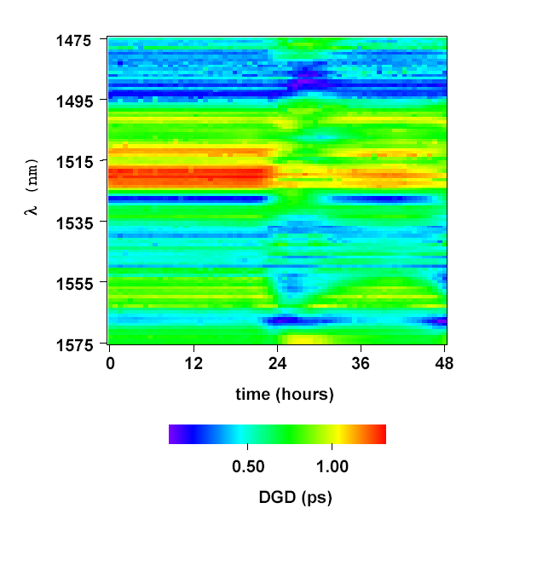
Figure 3 DGD measurement of a low PMD fibre link over time
Misha Brodsky, Peter Magill, Nicholas J. Frigo, AT&T Labs Research [5]

Another PMD measurement from Karlsson [6] also shows that the DGD of buried fibre does not change rapidly in time, see Fig.4. A characteristic time of 3 days is cited in the document to measure the correlation of the PMD vector change over time. On average the DGD changes less than 10% per day and the PSP changes 20 degrees in this time; the change was attributed to variations in temperature during the measurement period. Again there were six sections of the fibre exposed to the air in the fibre link, which were understood to induce this temperature dependent behaviour.
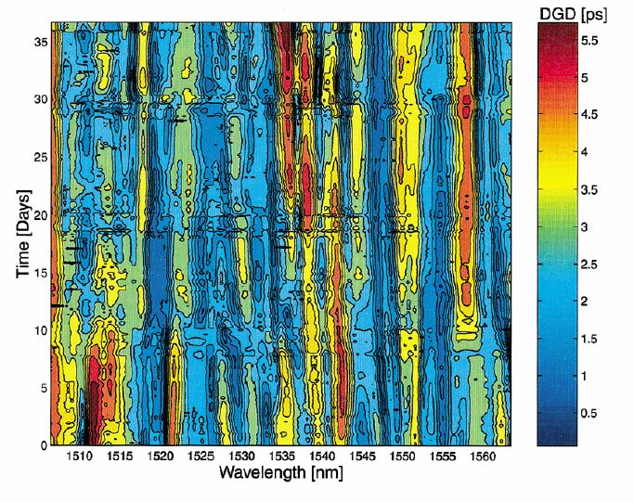
Figure 4 Long term PMD in buried fibre: from [6] Karlsson, JLT, 18, 7, 941 (2000)

The small intrinsic PMD of low PMD fibre makes its PMD value more sensitive to external perturbations such as temperature compared to other fibre. Temperature may affect the DGD in a deterministic way, and therefore should be held constant in any section of the link. However, the temperature change of the buried fibre is a relatively slow phenomenon. With proper isolation, especially at the splicing houses/manholes, the effect can be reduced. This certainly raises the hope that less jitter is possible in shorter time intervals. More analysis and measurement is required, as the sensitivity greatly depends on the fibre and cable type. As a guideline, the measurement of a low PMD link [5] showed that the DGD value of fixed wavelengths experienced changes within ±0.08 of the link’s mean DGD value per degree Celsius. Reducing the temperature change in the manholes therefore helps to limit the DGD changes. .

The PMD effect of the long fibre has another impact. The output SOPs will not only change differentially in wavelength, but also rotate together. This also needs to be characterised, as the receiver will not be a perfect receiver and therefore polarisation mode noise associated with the SOP rotation will be expected. The current line-correction system is immune to polarisation noise in the round-trip signal as the optical path is retraced in the orthogonal SOP [7]. Although the returning SOPs are held stable over time, the delivered SOP, which is at the mid-point of the optical round-trip, is not. The relation between the change of PSP, SOP and DGD is unclear at present, but they should be related in some way as they originate from the same physical mechanisms. Therefore, measuring the SOP change in time can hopefully provide some confidence in the stability of the buried fibre.

The other part of the distribution system is the fibre wrap, which allows the antenna to be rotated. This part is different to the buried fibre as its movement is deterministic, if vibration is ignored. Therefore, the PMD induced in this case should be a deterministic PMD which can be predicted and controlled. Careful design of the fibre wrap is necessary to make sure that the varying DGD and SOP change induced by the wrap is small, as the SOP conversion at the end of the fibre link effectively changes the PMD vector.

An active polarisation stabilizer may aid the SOP stability issue, but other questions remain over the use of such a device.

Receiver

The receiver includes the pre-amplifier, coupler, switch, pigtails and photomixer. The PMD for each of the passive components is typically less than 20 fs (but we are not sure about the optical switch). The PMD of the preamplifier might be the major contributor to the PMD of the receiver. Optical amplifiers are not usually specified with a PMD value. They contain optical isolators which have PMD of around 20 fs to 200 fs. For an EDFA, typical total PMD values are from 0.1 ps to 2 ps. The PMD of other amplifiers is still to be investigated. The polarisation dependent gain (PDG) of the amplifier and photomixer can also contribute to the phase jitter induced by the SOP fluctuations. Overall, the receiver has many birefringent components coupled in a random way and their DGD can be calculated.

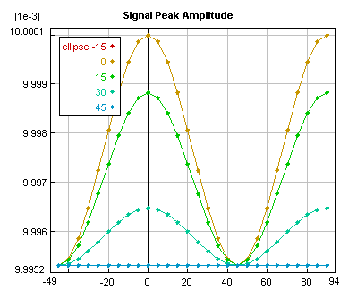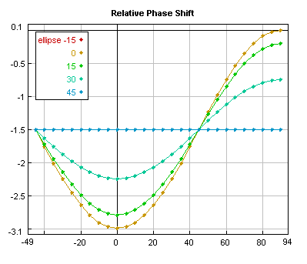Figure 5 RF signal amplitude and phase change for a 100 GHz signal when the input SOP rotates.
PMD = 0.1 ps. x-axis is the azimuth of the input SOP. Phase shift (RHS) is given in degrees.

Due to the polarisation mode noise, if during our measurement interval the SOP of the incident light can change from the fast to the slow PSP (or vice versa), the DGD of the receiver will be completely converted into LO signal jitter. To reduce the polarisation mode noise, either the input SOP rotation to the receiver needs to be stabilized, or an extremely low PMD and PDL receiver is needed. A simulation result of the RF amplitude and phase as function of the ellipse and azimuth (x-) of the input SOP is shown in figure 5. The PMD value is assumed to be 0.1 ps and the frequency is 100 GHz. A maximum of approximately 3 degrees phase change is expected (corresponding to a jitter of 0.1 ps) for linear polarisation throughout the rotation . The small PMD also induces a small SOPD of the two wavelengths, which modifies the amplitude of the signal.

Overall system outage consideration

Even if the SOP, DGD and PSP are proven to be stable over the measurement interval, there is still a possibility that the SOPs will become orthogonal to each other in the longer term. However, assuming that the DGD is low and fixed over the limited wavelength range, the maximum precession rate of the output SOP can be determined to calculate the lowest photomixing efficiency. When the PSP drifts to a certain point that the power in the fast and slow PSPs are equal, maximum SOPD can be expected. If it is always the case that the product of the max(DGD) and the LO frequency is much less than 1, then the SOPD is small and the RF power will not be reduced to zero.

The SOPD also has another impact when the antenna wrap is considered. It can be shown that if the two SOPs are nearly orthogonal to each other, the maximum timing jitter caused by the moving antenna can significantly increase to a level close to the signal’s period.

V. Suggestions

- The LO generator should be polarisation stable, and a high extinction ratio should be maintained at the output of the LO generator. Fusion splicing of the PM fibre is better than using connectors.

- The stability of the reference path in the LO generator should be considered as it directly affects the stability of the generated LO signal. This not only includes the propagation delay of the reference path, but also the polarisation stability. The PMD value and stability of the reference path are as important as those in the delivery path.

- To reduce transient effects in the distribution section, ultra low PMD fibre should be used. The consideration of techniques for PMD insensitivity to environmental changes is also important, especially for the low PMD fibre/cable. Finally, in the selection of the fibre, the PMD of spooled fibre and of laid cable should be distinguished.

- The buried fibre should not be exposed or attached in a un-insulated form to bridges anywhere, and should be isolated properly from the main sources of vibrations, such as roads.

- The effect of the fusion splicing of the fibre, although it should not be a concern, should be investigated, or, at least, consultations with manufacturers on this issue should take place.

- There should be no sharp bending of the fibre anywhere in the link. It is suggested that a bending radius no less than 0.25 m is used in the buried fibre part of the link, and a bending radius no less than 0.05 m for the antenna wrap/receiver (assuming approximately 10 loops for each case).

- No large PMD/PDL components should be used after the generator. In particular, care needs to be taken in the selection of optical switches and optical isolators.

- Fibre that needs to be exposed to the air, such as the cabling in the antenna cabins to the cryostat modules, must be kept short, as straight as possible, taped down and isolated from the environment.

- Tests measuring the phase of a delivered signal would be the most direct method of identifying the level of phase jitter induced in the link.

- System outage should be analysed further.

Polarisation stabilization techniques are worth investigating. If these are achievable, then the PMD requirement of the receiver can be relaxed, and possibly, a PM fibre wrap and receiver can be used, with improved performance.

VI. Discussion

Apart from the current dual laser LO baseline plan, there is a direct lower frequency analogue modulation plan, which might be able to deliver a LO signal better than the dual laser system. However, the phase jittering observed in previous experiments [1] was primarily due to the large PMD of the circulator, and possibly some contribution from the imperfect alignment of the SOP in the generator as well. As the circulator is removed from the link, the phase stability has been improved. Direct modulation, carrier suppressed or not, should not offer advantages, if the delivered signal is at the same high frequency. As the real instantaneous DGD is not flat or linear across the wavelengths, direct modulation produces many sidebands, and only makes things more complex. In the case that the carrier and all unwanted components are perfectly suppressed, the situation is very close to the dual laser system with a good polarisation alignment between the two lasers. The real advantage of the AM link system is due to its low delivery frequency, which may allow use of a less polarisation sensitive photodiode. However, even for very low frequency distribution, a temporal drift ceiling due to the random change of the DGD exists over long periods. In the short term, the SOP stability remains the same regardless of the delivery frequency. The polarisation sensitivity of the preamplifier, optical isolators and optical switches will be the same for high and low frequency receivers. Therefore, maintaining the stability of the fibre is vitally important regardless of the LO reference frequency distribution scheme.

Glossary:

AM: Amplitude Modulation
CD: Chromatic Dispersion
DGD: Differential group delay
D_{p}: PMD Coefficient
HBF: High birefringence fibre
ITU: International Telecommunications Union
LO: Local Oscillator
LBF: Low birefringence fibre
PDL: Polarisation dependant loss
PM(F): Polarisation maintaining (fibre)
PMD: Polarisation mode dispersion
PSP: Principal State of Polarisation
SM: Single Mode
SOP: State of Polarisation
SOPD: State of Polarisation Dispersion

References:

1. W. Shillue. ALMA Memo #483 “ALMA LO Reference transmission: Measurements of the RF phase fluctuation due to lightwave polarization effects”,

2. V. Ramaswamy, “Polarisation effects in short length, single mode fibres”, Bell Systems Technical Journal, pp. 635-651, 1978

3. H C Lefevre, “Single mode fiber fractional wave device and polarisation controller”, Electronics Letters, vol. 16 pp.778 -779, 1980

4 . N. Gisin, ‘‘Definition of polarization mode dispersion and first results of the COST 241 roundrobin measurements,’’ Pure Appl. Opt. vol. 4, pp. 511–522, 1995

5. M. Brodsky, “Polarization-Mode Dispersion of Installed Recent Vintage Fiber as a Parametric Function of Temperature”, Photonics Technology Letters, vol. 16, pp. 209 -211, 2004

6. O. Karlsson, “Long-term measurement of PMD and polarization drift in installed fibres”, J. Lightwave Technology, vol. 18, pp.941-951, 2000

7. M. Martinelli, “A Universal Compensator for Polarization Changes Induced By Birefringence on a Retracing Beam,” Optics Communication, vol. 72, pp. 341-344, 1989

