ALMA Memo #483
The ALMA 1st Local Oscillator Reference

Bill Shillue, Sarmad AlBanna, and Larry D’Addario
National Radio Astronomy Observatory (NRAO), 949 North Cherry Avenue, Tucson, Arizona 85721-0655
Ph: +1/520/882-8250, Fax: +1/520/882-7955

2004-09-29

Abstract
The ALMA 1st LO Reference system consists of a laser synthesizer, active line length correction, photonic distribution, and a photonic receiver. The phase stability and phase drift specifications are very ambitious, and the effort to meet them has led to small evolutions and improvements in the design. This memo gives a general description of the system, and documents its current measured performance levels, as measured in the laboratory.

Introduction
The Atacama Large Millimeter Array (ALMA) will consist of an array of 64 12-meter parabolic antennas operated as radio interferometers spanning 31-950 GHz. The antennas will be located on a plateau at 5500m elevation and will be separated by distances of up to 20 km [1]. The receivers require a phase-stabilized local oscillator (LO) coherent among all antennas [2,3].
These LO signals will be supplied by assemblies of YIG oscillators with relatively low (12-25 GHz) fundamental frequencies that get multiplied up to the higher frequencies by multiplier/amplifier stages. Each antenna and receiver has dedicated LO assemblies mounted directly to the receiver front ends. These local oscillators must have very low phase noise, and the phase drift between any two such LOs must also be very low. The LOs must actually be coherent across the wavefront of the astronomical signal; this requires that their phases be continuously adjusted in real time to account for the differential Doppler shift induced by the rotation of the earth. This is implemented by distribution of a centrally-generated reference signal to all antennas. The reference will be transmitted over buried optical fiber whose routing requires fiber lengths of up to 15 km. The reference signal is used to phase-lock electronic oscillators at the antennas. The total phase noise of the resulting LO is the sum of the intrinsic phase noise of the electronic oscillator outside the loop bandwidth and the reference noise within the loop bandwidth.

Requirements and Design Principles
The main 1st LO reference requirements are detailed in Table 1.
Requirement | Value | Notes
Frequency Range | 27-142 GHz | Design choice
Switching Speed | < 100 msec
Phase Noise | < 38 fsec | 1Hz—10MHz
Phase Drift | < 12 fsec | Over 1000 sec
Power Level | > 50 nW
Table 1- 1st LO reference: Main requirements
An important design decision was that the reference should be transmitted at the larger of the actual LO frequency or the highest frequency permitted by available technology, so as to minimize the need for frequency multiplication at the antennas and the corresponding multiplication of phase errors on the reference signal. Photodetector technology at 1.55 microns currently limits the maximum practical frequency to ~150 GHz [4,5].
In our design, the reference signal is a single sinusoid of variable frequency, depending on the desired astronomical observing frequency, and it is encoded as the difference in frequency between two optical carriers generated by two lasers. The first of these, called the master laser (ML), operates at a fixed wavelength and the second, called the slave laser (SL), is tunable and is phase locked to the master. Copies of the same two-wavelength signal are then distributed to all antennas.
By careful design, including the use of narrow-linewidth lasers and a fast phase-locked loop (PLL), phase-stable references are produced at the array center. To maintain this stability at each antenna, the electrical length of the fiber is actively stabilized by returning a portion of the master laser signal along the same fiber and measuring the round-trip phase change.

Implementation Description
Figure 1 is a high-level block diagram of the reference generation and distribution system. The blocks shown will be located in a building near the center of the array. Figure 2 shows the LO equipment at an antenna. The 31-950 GHz range of the receivers is actually partitioned into 10 bands, with separate RF and LO hardware for each; typical LO equipment for one band is shown.
The laser synthesizer in Fig. 1 contains the slave laser and the phase locking circuitry, and its output is the two-wavelength optical signal. The line length correction block contains a fiber line stretcher in the signal path along with circuitry to measure the two-way optical phase of the ML carrier. The line stretcher is driven by a servo so as to keep the phase constant. These two critical blocks will be described in more detail later in this memo.
At each antenna, the optical signal is delivered to a photodetector which acts as a mixer (photomixer) to recover the difference-frequency reference in millimeter-wavelength waveguide. The reference covers a portion of the range 27-142 GHz, depending on the receiving band. An electronic oscillator near the same frequency (consisting of a YIG-tuned oscillator in the range 12 to 25 GHz and a chain of frequency multipliers and amplifiers) is phase locked to the reference. For those bands that require an LO frequency above 142 GHz, the locked oscillator is followed by a frequency multiplier (cryogenically cooled) at a factor N = 3 to 9. The main purpose of these electronic components is to provide sufficient LO power for the receiver; if enough power were available from the photomixer, its output could in principle be used directly as the LO signal. In the chosen design, the only uncorrected phase drift comes from the power amplifier and cold multipliers, which are outside the PLL. Meanwhile, a portion of the optical signal is coupled off before the photomixer and passed through an optical frequency shifter (acousto-optic cell) driven at 25 MHz and then reflected at a Faraday mirror. The reflected signal returns by the same path to the LLC assembly at the center.
The length correction scheme effectively forms an optical interferometer over the entire (round trip) fiber length. This requires a high performance master laser capable of long-term fractional frequency stability better than 4x10⁻¹¹ and a coherence length ~50 km. A laser meeting these requirements has been developed by DiCOS Technologies, Inc., for the ALMA project and a prototype has been delivered [6].

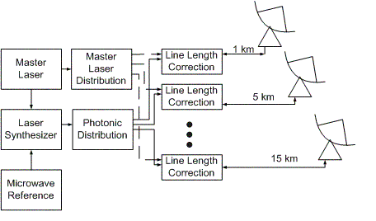

Figure 1 – System level schematic of the ALMA LO reference generation and distribution.

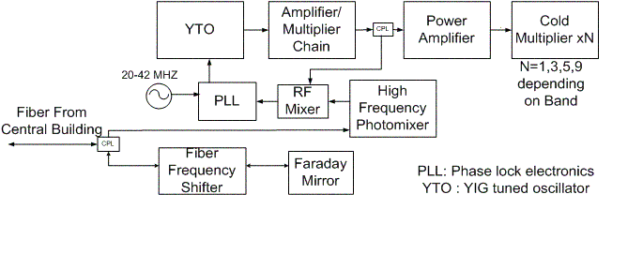Figure 2 – LO equipment an antenna, typical. A separate assembly of this type is provided for each band. The reference signal is optically switched to the one in use. An optical amplifier is expected to be required between the coupler and the photomixer but it was not included in the tests presented in this memo.

Laser Synthesizer
Details of the laser synthesizer design are shown in Figure 3. Its takes as input the master laser signal (frequency f_{M}) and a variable low-noise microwave reference (f_{R} = 8-12 GHz), and generates a second lightwave at optical frequency f_{S} = f_{M}+ nf_{R} +125MHz.
This might have been accomplished by various techniques such as comb generation in combination with phase locking [7], or injection-locking [8]. We have chosen to use electronic phase locking of a tunable DFB fiber laser, because it seemed the most straightforward and offered the least development time. The key elements of the chosen technique are: a narrow linewidth tunable slave laser, a fiber frequency shifter, a harmonic mixer and a high frequency photomixer. The fiber frequency shifter is the element that provides fast correction to the slave laser frequency and phase. The loop error signal is developed by the combination of the electronic harmonic mixer and high frequency photomixer. In addition, the tunable slave laser has very precise open loop tuning and high resolution to support rapid frequency changes and phase lock acquisition.

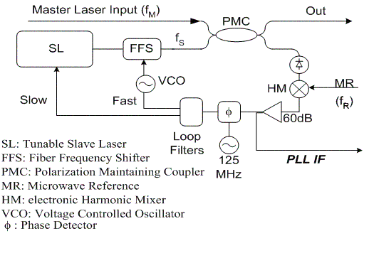
Figure 3 – Schematic of the laser synthesizer.

As shown in Fig. 3, the master and slave laser are combined in a polarization-maintaining coupler (PMC), so their polarizations are aligned. One branch of the coupler provides the output, while the other feeds a photomixer that recovers the difference frequency. (Not shown is the fact that 4 separate photomixers are needed to cover the whole 27-142 GHz frequency range. These are connected as required, along with matching harmonic mixers, by optical and electrical switches.) The microwave reference and harmonic mixer are used to downconvert the signal to 125 MHz. A conventional phase detector and Type II loop integrator then drive a voltage controlled oscillator near 100 MHz, which in turn drives a fiber-frequency shifter (FFS). The FFS is a commercial device modified to provide low acoustic delay of 100 nsec. To avoid having the slave laser drift beyond the range of the FSS (about 30 MHz), an additional slow loop drives a piezo-element that adjusts the frequency of the laser. A similar technique has been demonstrated by previous researchers at a lower difference frequency [9]. Fig. 4 shows a test result for an assembly using this technique to phase lock the slave laser at 108 GHz difference frequency. The output shown in Fig. 4 was measured at the laser synthesizer output by a W-band (75-110 GHz) waveguide photomixer and a spectrum analyzer outfitted with harmonic mixers for W-band operation. The RMS phase noise from 3 kHz to 3 MHz is 34 fsec for this measurement. This is thought to be mainly from the microwave reference, which was a laboratory instrument. Later measurements will include a custom-designed low phase-noise microwave reference. The loop IF was also measured directly by the spectrum analyzer and that is shown in Fig. 5. The IF noise was 0.013 radians from 10 Hz to 1 MHz. This indicates that there is some small amount of residual phase noise from the lasers. Extending the loop bandwidth is expected to further suppress this noise.

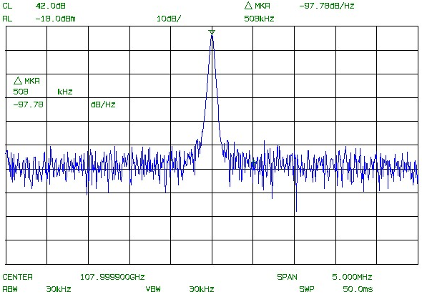
Figure 4 – Laser Synthesizer Output at 108 GHz (after photomixer). The measurement noise floor -97 dBc/Hz limits the measurement above 200 kHz offset. CF=108 GHz, Span=5 MHz, RBW=30 kHz

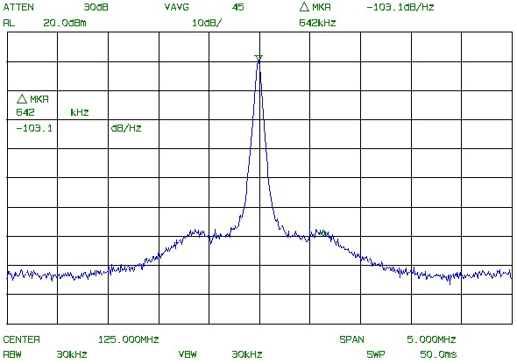
Figure 5 – Laser Synthesizer Loop IF. Scale is 10 dB/div, RBW=30 kHz, noise marker at 542 kHZ offset is -103.1 dBc/Hz

Line Length Correction
Stabilized RF signal distribution via fiber has previously been done by use of a single optical carrier modulated by a microwave signal [10-12]. These systems demonstrated phase accuracy down to 80-110 fsec. However, they were intended for distribution of RF phase at lower frequencies or for shorter fiber lengths. For ALMA, the phase drift must be small enough to allow operation at the highest LO frequency of 938 GHz. We have therefore chosen a technique based on an optical interferometer which offers the possibility of precision at a fraction of the master laser wavelength (1.5562 microns).
The line length correction subsystem is shown in Fig. 6. The two-wavelength laser synthesizer signal is adjusted in polarization and then passed through a 3- port polarizing beam-splitter assembly. The polarization is aligned so that all of the light passes through the beamsplitter. It then passes through a piezo-driven fiber stretcher assembly and the long fiber to the antenna. At the antenna end there is a 3-dB coupler, so that half of the light goes to the turnaround assembly and half goes to the photomixer. The turnaround assembly consists of the fiber-frequency shifter and a faraday-rotating mirror. The fiber-frequency-shifter contains an acousto-optic cell, and the light receives twice the frequency shift in this type of reciprocal arrangement [13]. The Faraday Mirror reflects 100% of the light in a polarization orthogonal to the incident polarization. This means that the outgoing and returning light is orthogonal everywhere along the fiber between the PBS and the Faraday Mirror [14]. Back at the PBS, the returned light is directed to the third port, where it is mixed with a sample of the master laser signal in a low-frequency photodetector, producing a product at the 50 MHz shift frequency. This signal is compared in a phase detector with a locally generated 50 MHz reference, and this phase is held constant by a servo driving the fiber stretcher.
To test the performance of this system, both the central and antenna components are located in the same room and the long fiber is simulated by a spool. The LO reference signal output, which normally drives the electrical PLL shown in Fig. 2, is then connected to a harmonic mixer driven by the same microwave reference f_{R} that drives the laser synthesizer. The antenna-end reference is thus downconverted to 125 MHz, where its phase is easily compared against the central phase represented by the IF of laser synthesizer’s PLL (see Fig. 3).

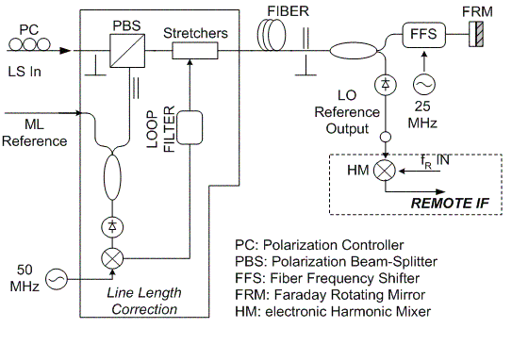
Figure 6 – Line length correction schematic, showing both central and antenna components, along with items used in the laboratory tests.
To date, we have only tested this line length correction system using lower frequency laser synthesizer sources over fiber lengths from 0-15 km. Fig. 7 shows the measured phase drift of an 18.6 GHz beatnote going through 10 km of optical fiber, with correction on and off. The RMS corrected phase over 10 sec time intervals is 0.22 degrees or 33 fsec. The correction voltage to the fiber stretcher is also shown. This test used a cascade of two commercially available piezo fiber stretchers. The first had a stroke of about 25 microns and bandwidth of 1kHz, and the second had a stroke of 5 mm and a bandwidth of a few Hz.

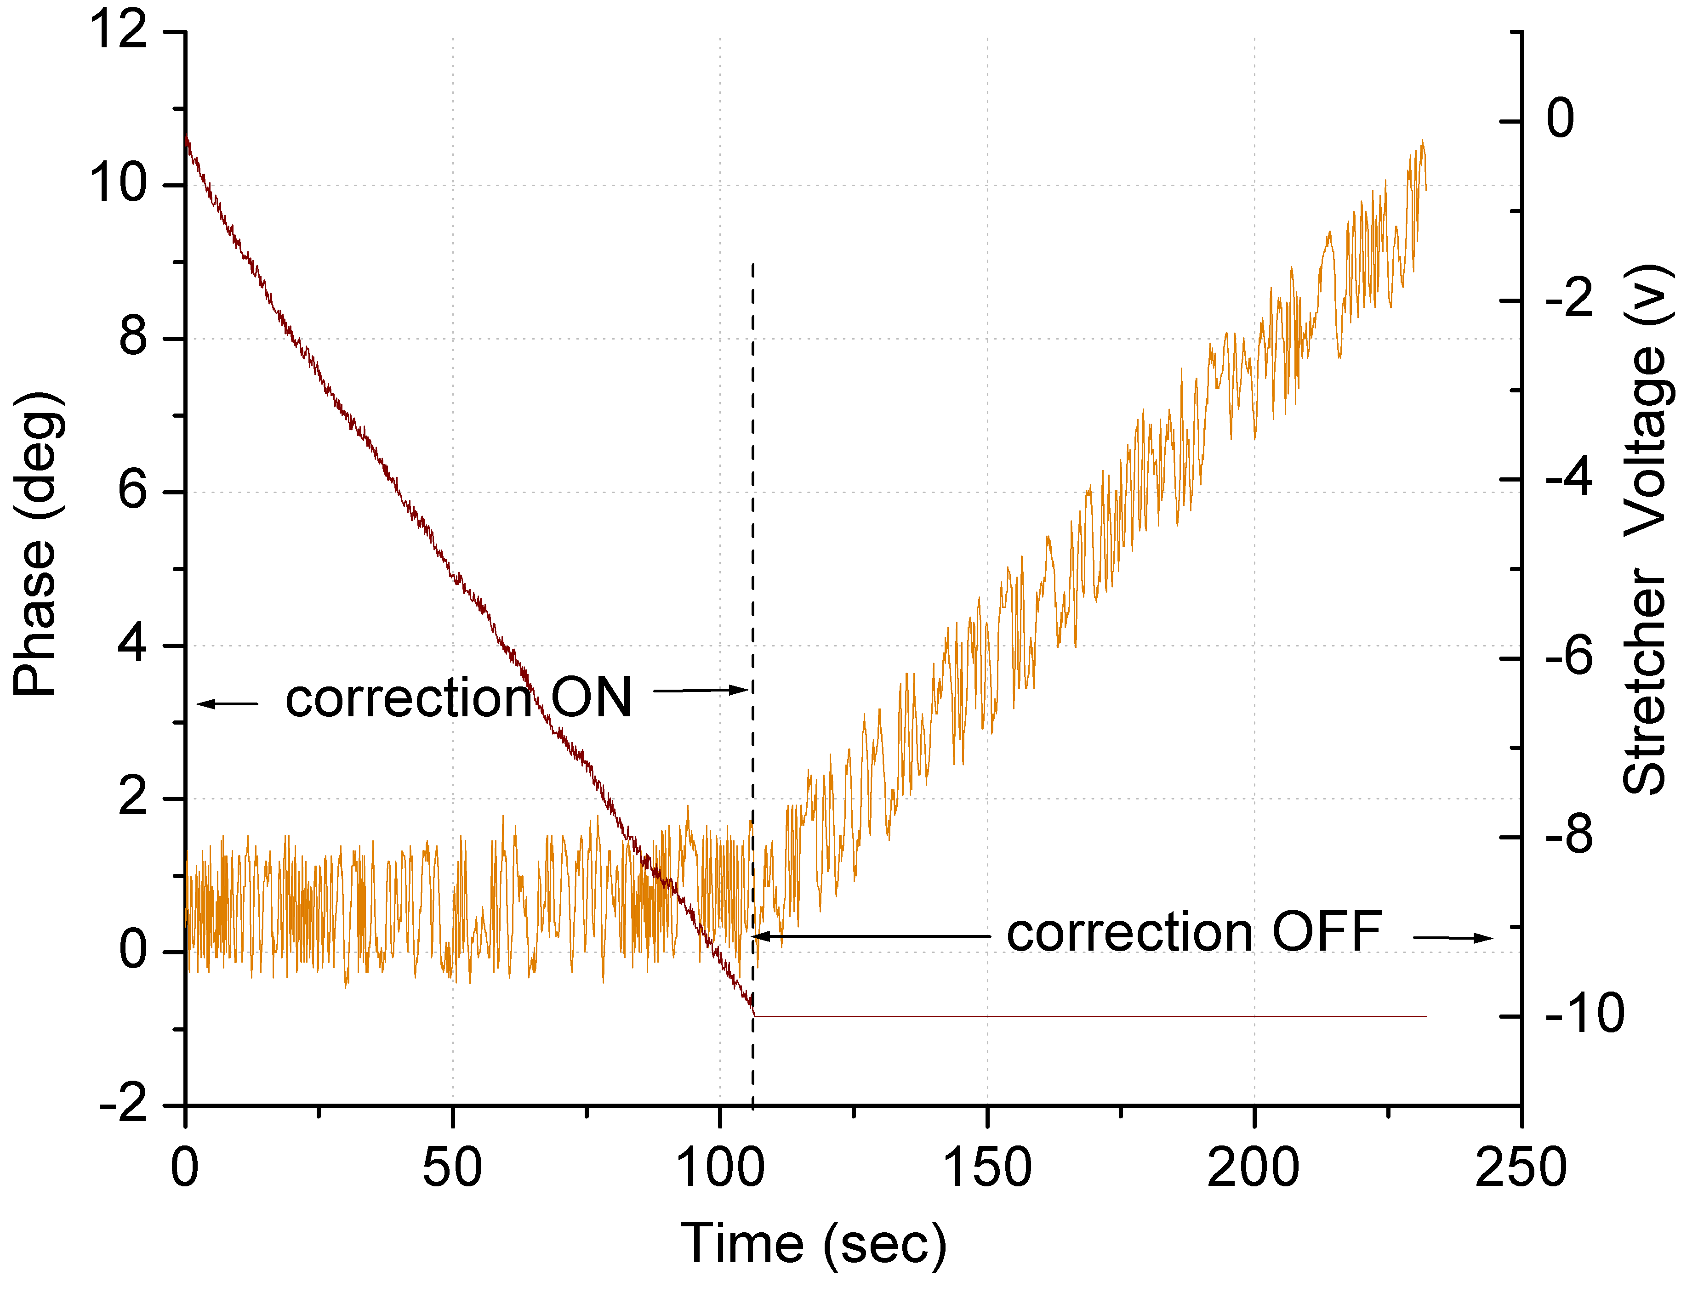
Figure 7 – Plot of the phase drift of 18.6 GHz signal through 10 km of fiber.

Conclusion
The ALMA 1st LO reference system is described and demonstrated. The LO reference distributes a high frequency, millimeter-wave signal with very low phase noise and phase drift.
These preliminary results have successfully demonstrated generation of a low phase-noise 108 GHz signal by phase-locking a tunable DFB fiber laser to a master laser at a difference frequency of 108 GHz. The extension to cover the required ALMA frequency range is straightforward. In addition, the principle of line length correction by use of a round-trip optical interferometer using a stabilized master laser has been demonstrated. Preliminary tests at 18.6 GHz and with 10 km of fiber show no phase drift down to the limit of the measuring apparatus at 33 fsec (0.22 deg RMS). Further measurements are planned at higher frequency in order to further reduce the measured RMS phase residual.
Further work on this system will be focused mainly on investigation of the performance of the system when the optical fiber carrying the LO reference is moving, as it will be when the ALMA antennas are in operation.

References
[1] A. Wootten, "Atacama Large Millimeter Array" Proc SPIE vol 4837, Feb 2003 pp. 110-118
[2] J. Payne, B. Shillue, A. Vaccari, “Photonic Techniques for Use on the Atacama Large Millimeter Array,” Proc. MWP 1999, pp 105-108
[3] J. Payne, B. Shillue, “Photonic techniques for local oscillator generation and distribution in millimeter-wave radio astronomy,” Proc. MWP 2002, pp. 9-12
[4] H. Ito, T. Ito, Y. Muramoto, T. Furuta, T. Ishibashi “Rectangular waveguide output unitraveling-carrier photodiode module for high-power photonic millimeter-wave generation in the F-band,” IEEE JLT Vol. 21, Dec 12 2003, pp. 3456-3462
[5] P. Huggard, B.N.Ellison, P. Shen, N. Gomes, P.A. Davies, “Efficient generation of guided millimeter-wave power by photomixing,” IEEE Photonics Tech Letters, Vol. 14, Feb. 2002, pp. 197 -199
[6] Jean-François Cliche, Christine Latrasse, Michel Têtu, Bill Shillue, Larry D’Addario, “A High-Coherence, High-Stability Laser for the Photonic Local Oscillator Distribution of the Atacama Large Millimeter Array,” SPIE Conf. on Astronomical Telescopes and Instrumentation, June, 2004
[7] P. Shen, P.A. Davies, W.P. Shillue, L.R D’Addario, J.M. Payne, “Millimetre-wave generation using an optical comb generator with optical phase-locked loops, Proc MWP 2002, pp. 101-104
[8] S. Fukushima, C.F.C. Silva, Y. Muramoto, and A. J. Seeds, “Optoelectronic Millimeter-Wave Synthesis Using an Optical Frequency Comb Generator, Optically Injection-Locked Lasers, and a Uni-Traveling-Carrier Photodiode,” IEEE J Lightwave Tech., Vol. 21, No. 12, Dec. 2003, pp. 3043-3051
[9] J. Ye, J. L. Hall, “Optical Phase Locking in the Microradian Domain: Potential Aplication to NASA Spaceborne Optical Measurements,” Optics Letters, Vol. 24, No. 24, Dec 15, 1999, pp. 1838-1840
[10] L. D’Addario, M. Stennes, “Transmission of Timing References to Sub-Picosecond Precision over Optical Fiber,” Proc. SPIE Vol. 3357, Symp. on Advanced Technology MMW, Radio, and THz Telescopes, March, 1998, pp. 691-701
[11] M. Calhoun, R, Sydnor, W. Diener, “A Stabilized 100- Megahertz and 1-Gigahertz Reference Frequency Distribution for Cassini Radio Science,” JPL Interplanetary Network Progress Report 42-148, Feb 15, 2002
[12] K. Sato et al, “Development of an Ultra-Stable fiber Optic Frequency Distribution System Using an Optical Delay Control Module,” IEEE Transactions on Instrumentation and Measurement, Vol. 49, No. 1, Feb. 2000, pp. 19-24
[13] L. Ma, P. Jungner, J. Ye, J.L. Hall, , “Delivering the same Optical Frequency at two places: accurate cancellation of phase noise introduced by an optical fiber or other time-varying path,” Optics Letters, Vol. 19, No. 21, Nov. 1, 1994, pp. 1777-1779
[14] M. Martinelli, “A Universal Compensator for Polarization Changes Induced By Birefringence on a Retracing Beam,” Optics Communication, Vol. 72, No. 6, 15 Aug 1989, pp. 341-344

