ALMA MEMO 433

2002: the driest and coldest summer

Ricardo Bustos

CBI Project
E-mail: rbustos@dgf.uchile.cl

2002 – SEP – 06

Abstract: This memo reports NCEP/NCAR Reanalysis results for the southern hemisphere summer of 2002 (December 2001 – March 2002). The data shows a very low amount of PWV as well as low temperatures, indicating that it has been the driest and coldest summer for the last 50 years. The results confirm the previous conclusions about interannual variability of PWV during the austral summer and that there is no climatological trend of increasing PWV for the Chajnantor area. The Reanalysis data of the surface temperature shows a decrease in average temperatures during the last three years. A direct relationship between the fraction of time when winds from the east are present and the average amount of PWV is also obtained. As we have previously shown there are two different seasons with different origins at the site: the summer (mid-December to mid-March) is related to a change in the region’s circulation and presents a high amount of PWV with the presence of easterly winds, and the winter (April to November) is more related to ENSO and the Pacific Ocean activities.

1. Introduction

Two different seasons are clearly determined on Chajnantor. The austral summer, from mid-December to mid-March, is dominated by a circulation change in South America, the South American Monsoon System (SAMS). The winter season, from April to November, is more related with the El Niño - La Niña (ENSO) phenomenon. El Niño (warm Pacific Ocean temperatures) produces a wet winter while La Niña (cold Pacific Ocean temperatures) produces a dry winter at Chajnantor.

Most of the precipitation and snowfall on the Altiplano occur during austral summer (called the Bolivian winter) and this is virtually the only water resource on the Altiplano. These events are mostly due to the deep convection over the Altiplano by transportation of moist air from the Amazon basin through an easterly/wet pattern and by seasonal changes of atmospheric circulation over South America. A typical signature of the Bolivian winter is the presence of an upper-level anticyclone (the so-called Bolivian high), which is an upper-level manifestation of the region’s summer monsoon (Lenters and Cook 1997, Grimm and Garreaud 1998). The position and intensity of the Bolivian high is intimately related to seasonal variations of the precipitation on the Altiplano. The increase of precipitable water vapor (PWV) is then controlled by easterly winds over the Altiplano during summer (Bustos, 2001).

The interannual variability of moisture over the Altiplano during the summer is still being investigated and it is known that it has a weak relationship with the ENSO phenomenon. However, different periods of high and low PWV (from 1 to 5 years) and no trend of increasing PWV were found in Bustos et al. (2000) using NCEP/NCAR Reanalysis data. A drier summer in 2002 was somehow expected since the previous summers had high PWV averages.

In this work, PWV and surface temperature data from NCEP/NCAR Reanalysis for the summer of 2002 were studied and compared with historical data. PWV data from Reanalysis are cross-correlated with on-site PWV data obtained from opacity measurements by a 225 GHz tipping radiometer located at the ALMA site. NCEP/NCAR Reanalysis is then used to determine a long-term study of PWV and surface temperature for the summer season. A relation between easterly winds and PWV during summer was also shown.

2. Data

NCEP/NCAR Reanalysis data is provided by the NOAA-CIRES Climate Diagnostics Center, Boulder, Colorado, USA, from their Web site at http://www.cdc.noaa.gov/. The data used in this work are monthly averages of PWV and surface temperature, from 1948 to May 2002, given for a grid point at Salar de Chalviri (67.5 W, 22.5 S, 4,029 m.a.s.l.) the closest point to the Chajnantor area (67.75 W, 23.02 S, 5,050 m.a.s.l.). The PWV data are also given four times per day (00, 06, 12, and 18 UTC) covering the period from February 12 to 28, 2002. Both PWV and surface temperature data are corrected in altitude for Chajnantor using the same procedure as Bustos et al. (2000).

From 1995 to 2000 and the year 2002, Chajnantor PWV data are calculated from opacity measurements by the 225 GHz tipping radiometer from NRAO. These data was obtained from the site characterization page maintained by Simon Radford (http://www.tuc.nrao.edu/mma/sites/Chajnantor/data.c.html). The 2001 PWV data are obtained from the 183 GHz radiometer provided by Guillermo Delgado. Meteorological data from 1995 to 2002 were obtained from the site characterization page maintained by Simon Radford.

Because of the use of monthly averages in this work, the summer is defined from January 1st to February 28th.

  - PWV

In order to validate Reanalysis PWV data for this summer, a cross-correlation with PWV measured on-site is done in 2.1.1. PWV historical data from 1948 is shown in section 2.1.2.

2.1.1 Cross-correlation

The 225 GHz radiometer did not work in January 2002 and was recovered on February 12. To cross-correlate the radiometer data with the Reanalysis results, the same procedures as in Bustos et al. (2000) were used. PWV values from opacity measurements by the 225 GHz tipping radiometer over 10.4 mm are eliminated and the data obtained 4 times per day (00, 06, 12, and 18 UTC) are produced by averaging the data 30 minutes before and after the time considered.

After February 22, Reanalysis gives negative PWV values. This data is not used for comparison with the radiometer data. Due to the difference in altitude (~1000 m.) between the grid point and Chajnantor, PWV Reanalysis data are multiplied by an altitude correction factor of 0.5063.

Figure 1.1 shows the 4 times per day PWV data from Reanalysis and the complete available PWV data from the 225 GHz radiometer for February 12 to 28. It is clear that the Reanalysis results follows the radiometer data during the event from February 15 to 18, although they are a bit underestimated. The next days of low PWV, Reanalysis has some discrepancy in the strength and timing of the diurnal cycle. During the 10 days of comparison from February 12 to 21, Reanalysis follows well the radiometer data, and, as concluded in the ALMA Memo No. 333, it can be used for long-term climatological studies.
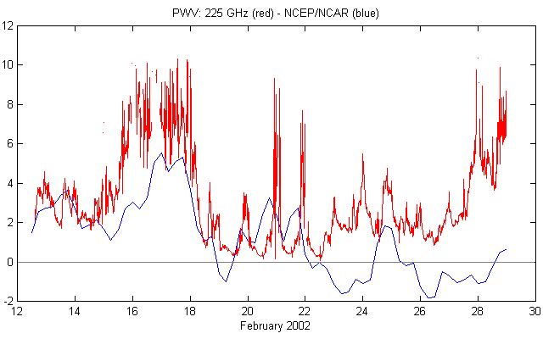
Figure 1.1: PWV comparison of Reanalysis (blue) and the 225 GHz radiometer (red) from February 12 to 28, 2002. Reanalysis well captured the event from February 15 to 18. From February 22, Reanalysis gives negative PWV values. For a cross-correlation from February 12 to 21, r = 0.678.

From the cross-correlation between the radiometer data and Reanalysis using the 4 times per day datasets from February 12 to 28, a correlation coefficient r = 0.530 is obtained and from February 12 to February 21, r = 0.678. In the previous work by Bustos et al. (2000), the correlation coefficient for the period 1995 to mid-2000 using the 4 daily measurement is r = 0.470 and for monthly averages, r = 0.788.

2.1.2 Long-term study

Because of the good correlation (r = 0.788) obtained in Bustos et al. (2000) between PWV monthly averages from the NCEP/NCAR Reanalysis and the 225 GHz radiometer, it is possible to compare the results for the summer of 2002 with those of the last 54 years using the Reanalysis data. Figure 1.2 shows a diagram of PWV from 1948 to May 2002 for the Chajnantor area.

January and February of 2002 present the lowest values since 1950. The years of 1948 and 1949 have even lower values, but the first 15 years of Reanalysis data are not very reliable due to the lack of meteorological observations in the Southern Hemisphere during that time. However, it is possible to use these data for studies of long-term climatological variations on Chajnantor and to conclude that the summer of 2002 was the driest for the last 50 years. This is seen also on the PWV summer anomalies plot for summer on figure 1.3. Summer values are obtained as the average of January and February for each year.

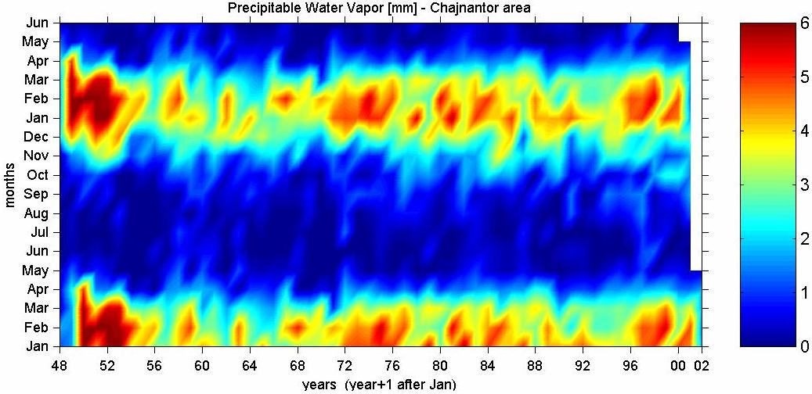

Figure 1.2: Annually versus Monthly values of PWV. It starts in 1948 to May 2002. The vertical axis is from January to December of one year and then it continues to June of the next, in order to have a better view of PWV summer variations.

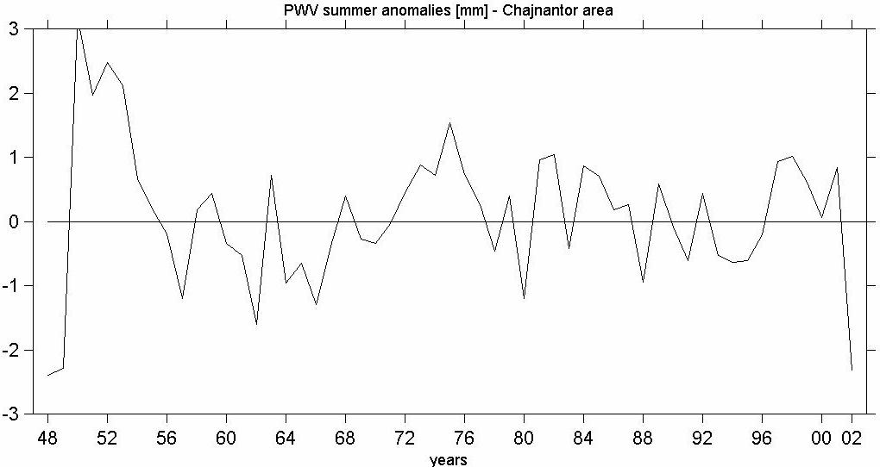

Figure 1.3: PWV summer anomalies. Summer is defined here as the average of January and February.

  - Temperature

Due to the ~1000 m difference in altitude between the grid point used in the Reanalysis and that of Chajnantor, the surface air temperature data obtained from the NCEP/NCAR Reanalysis are corrected to the altitude of Chajnantor by subtracting 6.4ºC. The cross-correlation done in Bustos et al. (2000) between Reanalysis and weather observations at Chajnantor for monthly temperature averages, gave a correlation factor of r = 0.865. Figure 2.1 shows a diagram of surface temperature from 1948 to May 2002 for the Chajnantor area. Figure 2.2 shows a diagram of temperature anomalies.

January, February, March, and April of 2002 monthly averages present the lowest values since 1948. Comparing these data with the historical values, it is possible to conclude that the summer of 2002 and the austral winter of 2000 (June and July monthly averages) have been the coldest in the Chajnantor area since 1948. The question is if this decrease in temperature over the last 3 years corresponds to a general trend or is part of normal variations similar to the early 50’s.

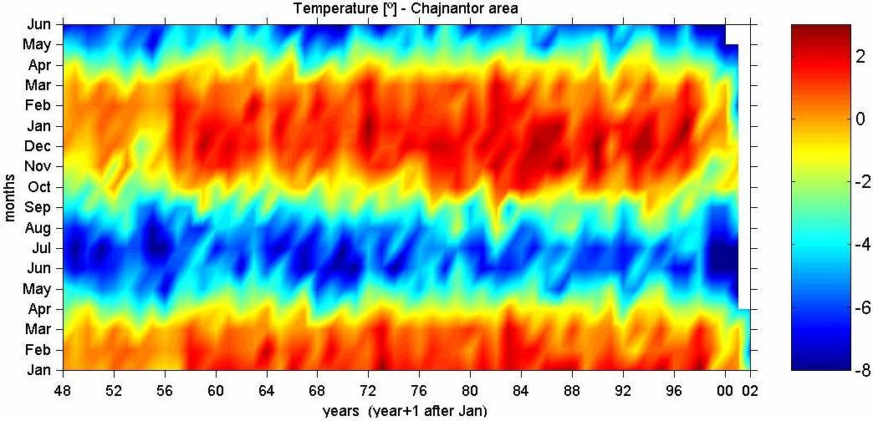

Figure 2.1: Annually versus Monthly values of surface temperature. It starts in 1948 to May 2002. The vertical axis is from January to December of one year and then it continues to June of the next, in order to have a better view of temperature summer variations.
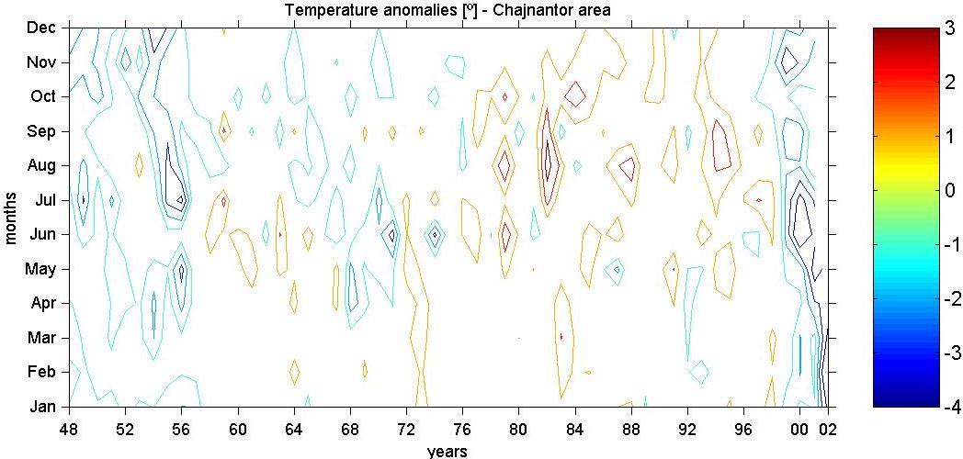
Figure 2.2: Annually versus Monthly values of surface temperature anomalies. It starts in 1948 to May 2002 and the vertical axis is from January to December.

3. Easterly winds

Calculating the amount of time (in %) with the presence of easterly winds during summer, a decrease of easterly winds is observed for this year, as seen in table 1. Since the water source comes mainly from the Amazon basin during summer, a decrease of PWV for this year is expected to be consistent with a decrease of easterly winds. By comparing the results with those from previous years, it is clear that a small fraction of time with easterly winds is correlated with a low amount of PWV (years 96, 98, and 2002) and a larger fraction of easterly winds is correlated with a high PWV (years 97, 99, 00, and 01). However, care has to be taken with the amount of time of available data in summer of 2000 and 2002.

Summer | Time with easterly winds  [%] | Available data  [%] | PWV  average  [mm] | Available data  [%]
1996 | 18.6 | 94.0 | 2.42 | 97.1
1997 | 37.7 | 86.4 | 5.08 | 82.1
1998 | 18.2 | 92.5 | 3.42 | 95.4
1999 | 29.7 | 87.7 | 3.68 | 83.8
2000 | 49.1 | 11.4 | 7.95 | 7.9
2001 | 44.9 | 93.6 | 5.23 | 68.4
2002 | 21.3 | 26.6 | 3.75 | 27.5

Table 1: Table that indicates the amount of time in summer with easterly winds [%] and the PWV average [mm] with their available percentage of data.
4. Conclusions

From the good correlation obtained between PWV from Reanalysis and on-site measurements for February 2002, and from the results in the work of Bustos et al. (2000), we believe that NCEP/NCAR Reanalysis can be used for long-term climatological studies.

NCEP/NCAR Reanalysis data show that the PWV during the summer of 2002 present the lowest values for the last 50 years. This anomaly is part of the interannual variability (figure 1.3) and does not seem at this moment to correspond to a general trend of decreasing PWV.

Reanalysis data show that the average temperatures for the last three years are declining and also show that the summer of 2002 has been the coldest since 1948. The question is whether this corresponds to a general trend or is a part of normal temperature variations similar to the early 50’s.

Due to the low PWV obtained this summer, the amount of time with the presence of easterly winds also decreased as expected from Bustos (2001). Table 1 shows a direct relation between these two variables and confirms the hypothesis that the water vapor originates in the Amazon basin.

These results confirm the previous conclusion in Bustos et al. (2000) that clear seasonal indications of higher humidity during austral summer in the Chajnantor area are present, with interannual variations and no trend of increasing PWV content. While the austral summer has an interannual variability of PWV with no relation to the ENSO phenomenon, the austral winter is indeed more directly related to ENSO.

Thanks are given to Simon Radford, Roberto Rivera, Fredrik Rantakyro, and Lars-Åke Nyman for useful discussions of this work.

References

Bustos, R., 2001: Summer climate over Chajnantor. ALMA Memo Series No. 379.

Bustos, R., G. Delgado, L. Nyman, and S. Radford, 2000: 52 years of climatological data for the Chajnantor area. ALMA Memo Series No. 333.

Grimm, A., and R. Garreaud, 1998: Report of the VAMOS working group on the South American Monsoon System (SAMS), chapter 3.2, Miami, Florida. http://www.met.utah.edu/jnpaegle/research/miami_report.html

Lenters, J. D., and K. H. Cook, 1997: On the origin of the Bolivian high and related circulation features of the South American climate. J. Atmos. Sci. 54, 656-677.

