ALMA MEMO #419
THE Y+ LONG-BASELINE CONFIGURATION TO ACHIEVE HIGH RESOLUTION WITH ALMA

Angel Otárola¹ & Mark A. Holdaway²

¹European Southern Observatory, Casilla 19001, Santiago 19, Chile. Email: aotarola@eso.org
²National Radio Astronomy Observatory, 949 N Cherry Ave. Tucson, AZ 85721-0655, USA. Email: mholdawa@nrao.edu

2002 April 12

Abstract: The ALMA array configuration design has been split into a compact array, an extended array, and a “zoom” spiral array which aims to connect them. The currently accepted extended array is a 14 km ring around Chascón. Based on Fourier plane coverage, resolution, operations, engineering, and environmental arguments, we present an alternative to the extended configuration: a Y-shaped set of zooming configurations, which naturaly grows out of the spiral zoom configurations. This set of preliminary configurations indicates a savings of about 20 km in roads and cables, and 35 fewer pads compared to the current ring design. It has smoothly varying resolution, which permits the observer to tailor the resolution to his requirements. Reconfiguration is much smoother with the Y configuration than the 14 km diameter ring. The most extended Y configuration obtains the same resolution as the 14 km ring array. However, in order to achieve these advantages, together with the highest possible resolution for the ALMA interferometer, we need to explore the possibility of extending the Science Preserve by at least two kilometres to the west of its current western boundary.

1.- A Brief History of “Y” and “O” Configurations
This section is a bit pedantic, but it is instructive in that it shows us how we got to the current design with a 14 km ring array around Chascón, and how we have a 4.5 km triangle around the Conway spiral configuration. There is nothing particularly fundamental about these decisions. On the other hand, using a Y configuration for the longest baselines is a viable alternative, which is in keeping with much of the design philosophy behind the Conway spiral configurations.
Many historical and even modern radio telescopes have the linear E-W configuration. The main advantage of the E-W configuration is simplicity. The most unfortunate aspects of an E-W array are the inability to perform snapshot observations and the inability to image low declination sources in two dimensions. Adding a N-S spur to the E-W track can fix both of these problems, and a Y can be thought of as a further modification. The experience at the VLA indicates that the ability to image far southern sources and to make snapshot observations has been greatly beneficial.
However, there are problems with the VLA's configurations. Any Y arrangement of antennas will have more short baselines than long baselines, and the exponential distribution on antennas along each arm further exacerbates this situation. In addition, the regularity of the placement of the antennas at the VLA results in very large sidelobes in the snapshot point spread function (PSF).
These two problems led Cornwell (1986) and Keto (1992) to write algorithms which sought to spread out the Fourier plane samples more. Cornwell's circular configuration and Keto's Reuleaux triangle configuration resulted in uniform (u,v) distributions with a maximum number of long baselines, and the ring became the leading configuration design for the MMA during the period 1986-1996.
In the mid 1990's, some concern developed over the uniform (u,v) coverage which the ring arrays produced. Specifically, the uniform coverage resulted in very large near-in sidelobes in the PSF, and it was thought that a Gaussian coverage might be better, since we often aim to achieve a Gaussian PSF restoring beam (Holdaway, 1996a). Defenders of the uniform coverage held on for many years. The main argument for the ring arrays seemed to be that it afforded the highest resolution for any given maximum baseline length. Supporters of the filled-type configurations, which produced a more Gaussian coverage, responded by saying that if you need higher resolution, go to a more extended configuration. Of course, that argument breaks down for the most extended configuration, and it was conceded that a ring array had a place for the most extended configuration.
With the basic acceptance of Conway's spiral configuration concept (Conway, 1998, 2001) with its Gaussian coverage, we were also led to cap the spiral configurations with a 4.5 km Reuleaux triangle to give the most resolution. In keeping with the “highest resolution per given maximum baseline” thought, we also ended up going towards a 14 km ring array for the ultra-long baseline configuration. This ring could only really fit on the site if placed around Chascón (Holdaway, et. al. 1996a; Kogan 2000; Webster, Jan. 2002 CDR). But with two ring-like arrays, we were being very wasteful of antenna pads. In addition, we are faced with a difficult problem: how can we smoothly go from the 4.5 km ring array to the 14 km ring array? We can't. Hybrids are difficult, and station reuse is difficult. To top this off, the terrain around Chascón is also difficult. This configuration set results in a difficult operational plan.
Early on in the configuration work at Chajnantor, Simon Radford had suggested that the longest baseline array extend more to the west to avoid Chascón and it's difficult terrain. As long as we were committed to a ring-type array, we could not use the land to the west. Consequently, we never tried to get much land to the west for the science preserve.
If we let go of the idea of using ring arrays for the largest configurations, the obvious idea to fill the void is to make a continuation of Conway's design philosophy. Continuing the three-armed spiral concept is not really feasible given the site restrictions we experience when going beyond the inner 4 km or so. However, we can continue with the philosophy that we move three of the inner antennas out beyond the outermost antennas to achieve an incremental improvement in the resolution of about 11%. This gains us a great deal in terms of simplicity in operations, consistency of design philosophy, using the configuration which provides the desired resolution, good use of hybrid arrays, and a great reduction in antenna pads and roads. We are back to the idea that if we need a bit more resolution, we just need to go to a larger configuration, rather than change to a different (u,v) distribution. It is a sensible idea, and our work here quantifies many of the ways that it makes sense.
We present a set of configurations called the Y+ arrays, which extend from Conway's longest baseline spiral configuration to 18 km baselines. The Y+ arrays are a viable alternative to the 14 km ring array. The “Y” refers to the general three-armed shape the configuration possesses, and the “+” refers to displacements away from a strict “Y” shape in order to achieve better (u,v) coverage and lower PSF sidelobe levels.

2.- Generating Trial Y+ Configurations
Conway's spiral configurations achieve an incremental increase in resolution of about 11% with each move of three antennas from the inside to the outside of the array. However, Conway caps off the spiral configurations with a 4.5 km Reuleaux triangle, to achieve highest resolution per given maximum baseline length as noted above. For the Y+ extension of Conway's spiral configurations, we ignore the 27 stations required for the Reuleaux triangle and seek to find a set of configurations which further increments the resolution by 11% for each move of three antennas, out to a maximum resolution which is equal to that of the 14 km ring. At λ=1 mm, the resolution of the 14 km ring is about 15 mas. This results in the need for about 14 configurations spanning from the outermost Conway spiral configuration to the outermost Y+ configuration.
To achieve this set of Y+ configurations with incrementally increasing resolution, we developed a mask which would push the configuration into the general shape of a Y (without any hard requirements of straight arms, which would result in too regular a sampling of the Fourier plane and large snapshot sidelobes), and adopted Boone's algorithm, which seeks to generate an array configuration with a desired Fourier plane distribution (i.e., resolution).
2.1- Topographical Mask
The topographical mask is the most important input into the process of generating the Y+ configurations. The existing mask (Butler, 2001) limits the maximum slope across any pixel to 5%. Road builders have implied that this may be too conservative, and indeed this results in a mask which is highly restrictive in it's outer regions. Furthermore, the mask did not go far enough to the west to produce a long baseline Y configuration with the required 15 mas resolution at 300 GHz, but this was mainly due to the limits imposed by the science preserve. For the new topography mask we choose the west border to be located at an altitude which matches the altitude of Pampa La Bola on the northeast side of the Science Preserve (4750 m).
We have already mentioned the “circular” logic (pun intended), which resulted in the boundaries of the Science Preserve excluding long baselines to the west. So, to permit a Y-shaped long baseline configuration, we added by hand in the AIPS++ software package some real estate to the mask which was previously inaccessible because of the 5% slope or the boundaries of the science preserve. These are mainly regions to the west and the south which one of us (Angel Otárola) has visited and are very likely to permit antennas. To be sure, we will need to investigate each site carefully before a more final version of the Y configuration is accepted, but for early costing comparisons, this is a reasonable approach.
In addition to adding some regions to the mask, we also found it necessary to take away some possibilities which the 2001 mask permitted. Any optimisation algorithm not facing hard constraints will tend to put antennas away from three straight arms to reduce grating responses. However, in order to make an economical Y-shaped array, we need to minimize the costs associated with roads and cables. So, we are in a bind between putting things in straight lines to save on money and putting things all over to save on sidelobes. Without a great deal of understanding with regard to the details of this optimisation, we have restricted regions in the mask which seem to us would be too costly to locate antennas, leaving a very rough, wide, and not very regular three-armed shape for the mask to guide the algorithm in its placement of antennas.
The job of the optimisation algorithm is to place the antennas optimally within the confines of this mask. The mask, which we used to generate the incremental instantiations of the Y+ configuration, is shown in Figure 1.
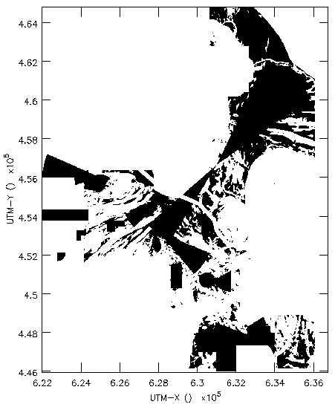
Figure 1: Topographical mask used to generate the Y+ configurations. This mask is a modification of the previous mask produced by Butler (2001).

2.2.- Using the Boone Algorithm
Frederic Boone's algorithm (Boone, 2001) arranges the antenna pad locations in such a way that the Fourier plane coverage comes closest to the desired azimuthally symmetric Gaussian distribution. It accommodates a topographical mask, maximum and minimum baseline constraints, and permits antennas to be fixed, so it seems like an ideal candidate to perform the optimisation we require. It does not explicitly minimize holes in the Fourier plane or minimize PSF side lobes.
To drive Boone's algorithm, we manually selected three inner antennas to be moved, incremented the size of the Gaussian Fourier plane distribution and the maximum allowed baseline by 11%, and selected initial locations for the antennas which were permitted by the mask, ran the Boone algorithm, and then repeated the whole procedure for three more antennas to make the next configuration. The algorithm took about 20 s to find locations for the three movable antennas. On occasions, the algorithm had difficulty finding what we judged to be a good antenna location. For example, sometimes several antennas were clumped together at the edge of a permitted region in the mask. Sometimes, when the algorithm was having a particularly difficult time placing an antenna, we would select a location for that antenna and optimise the remaining two antennas for that configuration.
This procedure worked pretty well, especially in the early stages when most of the rest of the antennas were at regular Conway spiral configuration locations. However, as the procedure progressed to longer and longer baseline configurations, the majority of the fixed antenna locations were pads chosen in earlier iterations of the algorithm, but in a very different context (i.e., optimising those locations with respect to inner stations which were not vacant as we moved the antennas further out). The algorithm seemed to be clumping points in the Fourier plane. Starting at about the eighth Y+ configuration, the Y-shaped topography eventually results in a six-sided star-shaped Fourier plane snapshot coverage, reminiscent of the VLA's coverage. This is inevitable, and is not a major problem. It is ameliorated by longer tracks (i.e., 2-4 hours), in which the points of the stars rotate into each other via earth rotation synthesis.
The antenna layouts and snapshot (u,v) coverage for each of the Y+ configurations are shown in order for configurations 1 through 14, in the figures included in the A Appendix.
As there is no explicit optimisation for the holes or clumps in the Fourier plane, just of the overall distribution, it might be that this algorithm can't do much better than the results we have obtained for this preliminary work on the Y+ configuration. However, we feel that a modification of the Boone algorithm, which optimised all of the Y+ configurations simultaneously, would alleviate a large part of the problems we see in the Fourier coverage of the longer baseline Y+ configurations.

2.3.- Configurations to Provide Resolution Increments
The design philosophy behind the set of Y+ configurations is intended to provide a set of configurations with incrementally increasing resolutions, out to the highest resolution we require. To verify that this has worked, we have calculated the beam shapes for each configuration for a source at δ= -53°, for a transit snapshot and for a six hour integration, and for both naturally and uniformly weighted data. These results are included in Tables 1 and 2 respectively. For the uniform weighting, a 512 x 512 image with cell size equal to 1/3 of the minor axis of the fit beam was used. This was an iterative procedure, with a first pass to fit the approximate beam shape to determine the cell size. It was found that a substantial change can result from this two-pass procedure.

3.- Preliminary layout for access roads and utilities to all antennas
3.1- Available tools

In order to estimate the total length of roads necessary to access all the antennas in the Y+ configurations we have made use of some existing tools including: the existing 10 m horizontal resolution topography maps [13], and AutoCAD® version 2000. The available highest resolution topography maps were produced through the aerophotogrametric restitution of aerial photographs available for the entire Chajnantor site and it’s surroundings.

Configuration | Snapshot |  |  | Six hour tracks
 | B_{maj}  [mas] | B_{min}  [mas] | B_{pa}  [deg] | B_{maj}  [mas] | B_{min}  [mas] | B_{pa}  [deg]
0 | 75.8 | 75.3 | 4.0 | 81.8 | 74.5 | 89.5
1 | 68.0 | 66.6 | 1.1 | 72.4 | 66.8 | 89.6
2 | 61.6 | 60.2 | 1.5 | 65.4 | 60.5 | 89.4
3 | 55.4 | 54.9 | 10.1 | 59.7 | 54.4 | 89.0
4 | 50.6 | 48.7 | -0.6 | 53.0 | 49.6 | -89.9
5 | 46.9 | 44.5 | -22.0 | 48.9 | 45.5 | -77.7
6 | 43.0 | 40.2 | -31.2 | 44.8 | 41.2 | -71.8
7 | 39.0 | 36.4 | -29.7 | 40.5 | 37.2 | -71.2
8 | 34.6 | 32.5 | -38.0 | 36.5 | 33.0 | -74.0
9 | 31.4 | 29.5 | -45.6 | 33.0 | 29.8 | -75.0
10 | 28.1 | 25.9 | -41.4 | 29.4 | 26.3 | -71.8
11 | 25.0 | 23.3 | -33.1 | 26.1 | 23.8 | -71.9
12 | 22.8 | 20.5 | -40.7 | 23.8 | 21.2 | -69.7
13 | 20.2 | 18.3 | -65.9 | 21.4 | 18.3 | -77.6
14 | 15.1 | 14.0 | 75.7 | 16.4 | 14.0 | 83.7
Table 1: Beam shape for naturally weighted data from each configuration at 300 GHz. The “0” configuration is Conway's most extended purely spiral configuration. The 14th configuration is made by moving 9 antennas instead of three so as to provide 15 mas resolution. For natural weighting, going to long tracks results in larger beams due to foreshortening of E-W baselines.

Configuration | Snapshot |  |  | Six hour tracks
 | B_{maj}  [mas] | B_{min}  [mas] | B_{pa}  [deg] | B_{maj}  [mas] | B_{min}  [mas] | B_{pa}  [deg]
0 | 64.6 | 60.3 | 1.9 | 49.8 | 47.0 | 82.6
1 | 57.8 | 52.0 | 2.0 | 41.7 | 41.1 | 34.2
2 | 52.4 | 47.2 | -1.1 | 38.0 | 37.6 | -74.5
3 | 46.4 | 43.6 | -0.6 | 36.0 | 33.7 | -86.6
4 | 42.6 | 37.8 | 0.0 | 30.8 | 30.5 | -63.1
5 | 39.7 | 35.1 | -12.3 | 30.1 | 28.0 | -54.5
6 | 36.1 | 32.0 | -24.1 | 28.1 | 25.0 | -65.1
7 | 32.8 | 28.6 | -28.4 | 25.6 | 22.1 | -61.4
8 | 28.3 | 25.8 | -36.1 | 22.6 | 19.1 | -86.2
9 | 25.6 | 23.4 | -38.8 | 20.9 | 17.7 | -79.4
10 | 22.3 | 20.4 | -43.1 | 17.7 | 14.8 | -79.0
11 | 20.2 | 18.2 | -32.3 | 15.7 | 13.9 | -72.6
12 | 18.3 | 16.3 | -41.5 | 14.6 | 12.4 | -70.5
13 | 16.5 | 14.0 | -56.8 | 13.6 | 10.0 | -67.5
14 | 14.2 | 14.0 | 87.0 | 11.9 | 10.1 | -86.3
Table 2: Beam shape for uniformly weighted data from each configuration at 300 GHz. The "0" configuration is Conway's most extended purely spiral configuration. For uniform weighting, going to longer tracks results in smaller beams due to more far out (u,v) cells being sampled; the inner cells which are being over-sampled do not count with any higher weight.

3.2- Criteria used for the layout of access roads to each antenna pads

Before going into the criteria used for the layout design of roads, we would like to mention the fact that our main goal in this document focuses around the Y-shape high-resolution configuration. Hence, in the design of access roads we have only considered the access to those antenna pads, which are exclusively part of the high-resolution configuration. In the same way, and in order to get a first comparison done with the 14 km ring array, we have found -using the same criteria- a possible way to get access to all the antenna pads for the 14 km diameter ring and the 4.5 km triangle proposed by John Conway at the 2002 January ALMA configuration CDR. There is still much work to be done towards getting a final high resolution array for ALMA so that the configuration proposed here, so Conway’s 14 km ring must be considered as preliminary designs.

Once we got all pad’s coordinates necessary to accomplish the Y-shape configuration, out of the antenna position optimization procedure, we added them to the AutoCAD® version of the selected topography map. From this point we adopted the criteria summarised in table 3 to find a possible way to access all antenna pads.

Criteria | Concerning… | Description | Justification of the criteron
1 | Public roads | Avoid use of the highway or any other public road. | For transportation of oversize or overweight equipment on public roads, coordination with the public roads office and police escort are required.
2 | Antenna pads | Avoid isolated antenna pads. | Isolated antenna pads can be consider for re-optimisation to miminise the access cost.
3 | Gas pipeline | Use of available crossing points to move antennas over the existing gas pipeline. | This criteria match the existing agreement between ALMA and GasAtacama Company to use three existing crossings to go over their infrastructure. These crossing points were established at the time GasAtacama deployed their pipeline at the site. However, if for technical reasons we required new crossing points, these can be done at the expense of the ALMA budget previous modification of the current agreement.
4 | Existing routes | Use of existing dirt roads as main routes to access the antenna locations. | This criterion is based on the assumption that improving existing dirt roads must be less expensive than building new ones.
5 | Roads in other configurations | Use of roads, which are part of the compact and intermediate configurations. | Here the whole idea it was to foreseen the access to the intermediate configuration as part of the access to the outer antenna pads.
6 | Topography | Follow reasonable slope (less than 10%) based on the available topography maps. | The maximum slope recommended for the antenna transporters is 10%. In finding ways to access the antenna pads we kept this recommendation in mind. However, there are cases where the approach to the antenna pad can be done from may directions within this slope range.
7 | Flexibility | In this first approach to the roads layout we looked for paths providing more flexibility in future iterations of the configuration design. | Sometimes the access to a particular antenna can be done from many directions and having almost the same distance from the nearest road. In this cases we adopted the path which give us more flexibility to add new antennas or to move antennas around in future optimization without affecting the access to neighbor antennas.
8 | OSF main road | Use of the road connecting the OSF and observatory sites to access some antenna pads. | The implementation of this criterion is a bit matter of speculation, since we don’t know yet which of a few options is going to be adopted to bring antennas from the assembly station at the OSF up to the Array site. However, in any case the sharing will be almost the same.
Table 3: Criteria used for the layout of access roads to the Y+ and 14 km Ring configurations

3.3- Preliminary layout of access roads for the Y+ and the 14 km diameter ring configurations

Figures 2 and 3 show a possible implementation of the access roads to each antenna pad using the criteria explained in table 3. These figures are included here for completeness and we used them to compute the total length of roads required for the Y+ and 14 km diameter ring configurations. In order to get a more clear view of how the roads are distributed over the site, we have classified the total length of roads in some categories that match the criteria used to get them. A summary of our calculations can be seen in table 4.

Item | Description | 14 km diameter Ring  (km) | Y+ Configuration  (km) | Comments
1 | Distances measured over existing roads. | 23.4 | 26.7 | These are basically the east access road to Chajnantor through Pampa La Bola, and the dirt road crossing the site to the southeast in the direction of Cerro Aspero.
2 | Distance of total connecting road-branches necessary to access each antenna pad in the given configuration. | 49.5 | 43.0 | These road branches are measured from the crossing point with existing dirt roads.
3 | Distance estimated for the road branches necessary to get access to isolated antenna pads. | 6.0 | 0.0 | Moving the isolated antennas to another place, without affecting seriously the beam shape or uv coverage can eliminate this item.
4 | Distance over roads, which are necessary to access antenna pads in the inner configurations. | 4.7 | 7.0
5 | Share with the OSF-Array Site road. | 0.0 | 6.5 | Since the OSF site is located to the west of the Chajnantor site, the only one configuration sharing some of the road is the Y+. The ring array goes to the east of Chajnantor around Cerro Chascón.
6 | Total length of roads share by the Ring and Y+ configurations. | 30.0 | 30.0 | This is the length of access roads are common to any of the two possible long baseline configurations.
7 | Estimation of the length of roads necessary to access the external Reuleaux triangle in the largest intermediate configuration. | 11.2 | 0.0 | The external Reuleaux triangle is not necessary in the case of the Y+ long baseline configuration. Here there is important savings in the total length of roads required.
8 | Total length of roads (sharing not considered): 1+2+3+4+7 | 94.8 | 83.2
9 | Total length of roads minus sharing (1+2+3-4-5) | 90.1 | 69.7 | Subtracting the length over the roads share with other facilities we must have at the site.
Table 4: Classification of access roads and total length of roads in the different categories.

Considering the important factor that the external Reuleaux triangle, used for the highest resolution intermediate configuration, will not be required within the Y+ long baseline concept, there is here an important saving in the total length of roads for about 20 km. We have estimated, the 20 km of fewer roads in the case of the Y+ configuration, might amount to the 12% of total length of roads required for the whole ALMA project. In addition, the Y+ configuration will not require any roads over the rough terrain to the southeast of Cerro Chascón.

4.- Advantages of the Y+ configuration

The initial motivation for a Y-shape extended configuration was to utilise flatter topography to avoid antenna placement in the rough are to the SE of Chascón. This section of the science preserve consists of very rough terrain with a highly complex geomorphology consisting of hills, deep creeks (Quebradas ) and cliffs, besides the existence of a small lagoon right to the south of Cerro Chascón. However, the advantages we see in a Y configuration are much greater than these and we have summarised them in the following categories: operational, scientific, engineering and environmental.

4.1.- Operational advantages

One of the main operational advantages has to do with the reconfiguration of the whole array. The Y+ long baseline configuration is basically an extension of Conway’s second highest resolution spiral into a Y-shape configuration, to be extended to the point of achieving the same resolution than a 14 km diameter ring. As in the case of Conway’s spiral, to achieve the intermediate configurations, we can adopt the same procedure of moving three antennas at any giving time (Conway 2001) to go from any two consecutive step resolutions in a continuous mode. The possibility of moving three antennas at any given time also matches the recommendation proposed for the ideal number of antenna transporters need it to operate ALMA (Radford 1999). The exception to the rule is the case of the highest resolution configuration in the Y+ concept where 9 antennas need to be moved to accomplish this configuration. In this case three days will be necessary to complete the re-configuration procedure. The final configuration can be achieved in less time provided that good weather conditions allows more than one antenna move per antenna transporter. Table 5 has been included in this memo to illustrate this point.

Item | Operations | 14 km Diameter Ring | Y+ | 14 km Ring  Antennas to move | Y+  Antennas to move
1 | Number of configurations from compact to Conway’s second most extended intermediate spiral. | 19 | 19 | 105 | 105
2 | Highest resolution spiral | 1 | 0 | 27 | 0
3 | Number of configurations from Conway’s second most extended intermediate spiral to the second longest baseline configuration. | 0 | 13 | 0 | 39
4 | Highest resolution configuration. | 1 | 1 | 56 | 9
 | Total number of antennas moves to achieve a complete cycle. |  |  | 132+56 | 153
 | Cycle time, this is purely an arithmetic exercise but very realistic in the case of the Y+ concept. In the case of the Ring; operations schedule and costs might place some strong limitations (Memo 265). |  |  | 63 days/cycle  Shortest cycle. | 51 days/cycle Shortest cycle.
Table 5: Number of configurations and antenna moves to achieve them.

More flexibility to the operation of the entire array is another advantage. Just like in the case of the spiral configuration (Conway 2001), we can operate the array as a set of fixed arrays or in continuous mode. This operational flexibility involves also a scientific flexibility of the array because we can keep ALMA at any given configuration (resolution/sensitivity) as required to achieve the goals of a particular scientific program. Besides, the Y approach always keeps ALMA in an optimized uv-coverage in case antenna movements are not possible because of weather reasons, while there are no viable hybrids between the 4.5 km triangle and the 14 km ring arrays. We can call this a flexible re-configuration schedule capability of the Y+ configuration.

Continuous reconfiguration provides an easier frame to schedule activities for the concerned staff. In this frame the Array Configuration Staff will periodically have well defined activities to be performed, including: reconfiguration of the array and maintenance tasks. In the case of the 14 km diameter ring all antenna transporters and all array reconfiguration groups will be required, to move as many antennas as possible to minimise the downtime of the whole array. This pressure on the staff schedule can last for up to two weeks followed by a long period of time when their participation, at least for reconfiguration, will not be required.

4.2.- Scientific advantages

The main scientific advantages we can identify so far are based on the fact the Y+ scheme consists of a continuous set of sub-configurations. Hence, this also provides a continuous range of resolutions for the synthesized beam, ranging from about 1.5 arc-second to 15 mas at λ=1mm, in an entire configuration cycle. Tables 1 and 2 show the resolutions for the Conway’s second most extended up to the longest baseline Y+ configurations. This capability will better match the resolution/sensitivity requirements of a particular astronomical observation.

The fact we only need to move three antennas at a time to go from a given configuration to the next one in resolution, with the exception of the highest resolution step where 9 antennas have to be move, allow us to achieve a complete configuration cycle in 51 days. This gives us a lot of flexibility to schedule scientific programs over the year. Here there is a great advantage comparing to the case of the ring configuration, where due to operational limitations, a cycle of 18 months for the highest resolution array to be hold for longer period of time was suggested as a good compromise between the operational challenges this configuration presents and the number of scientific programs which might required this high resolution (Radford 1999). The possibility of having a higher re-configuration cycle has been already considered (Holdaway 1998; Yun & Kogan 1999) and is desirable to achieve a more efficient scientific turnaround and to deal better with the seasonal variations of the weather conditions at Chajnantor.

In order to achieve the same natural resolution as a ring, the most extended Y+ array must have the same average baseline as the ring array. Since the Y+ configuration is centrally condensed, it will end up having longer maximum baselines (18 km) than the ring array (14 km) in order to achieve the same resolution. However, this can actually be turned into an advantage for the Y+ array. A ring array, with nearly uniform Fourier plane coverage, will have essentially the same resolution for naturally or uniformly weight data. The centrally condensed Y+ array's Fourier plane coverage, with uniform weighting emphasizing the long baselines over the shorter ones, will actually have substantially better resolution than the ring array. Table 2 indicates a maximum resolution of about 11 mas. In practical situations, some form of Briggs weighting would be used, so the full uniform weighted resolution would not be realized, but also the sensitivity loss would be minimized. Yet, the uniform weighting resolution stands as a reasonable sort of resolution limit for bright sources not limited by thermal noise.

The larger resolution range the Y+ configuration gives to ALMA, together with the possibility to achieve a higher frequency reconfiguration cycle over the year, provides a better opportunity to match the desired resolution for a particular observation, reducing this way the necessity of tapering the data and by consequence is possible to achieve a higher sensitivity in the final reconstructed image. This characteristic has been already mentioned as a desired property (Yun & Kogan 1999) stating that resulting loss of sensitivity can be avoided if the observation is conducted in a configuration better matching the desired resolution. Besides, many scientific programs will required to compare images of complementary molecular transitions which are at different frequencies, and by consequence will have different resolutions (Holdaway 1996b). The Y+ configuration has the advantage of providing more flexibility to accomplish this scientific goal.

Also, since the Y+ array is an extension of the spiral concept adopted for the intermediate configurations of ALMA, we share the property of allowing a good level of hybridisation. Hybrid configurations will provide ALMA with circular beams when observing sources at low elevations over the north sky from Chajnantor.

4.3.- Engineering advantages

From the engineering point of view, the Y+ configuration presents some important advantages related with the deployment of the ALMA infrastructure. One of the most important has to do with the fact that to accomplish the highest resolution (15 mas @ λ=1mm) only 213 pads are necessary. This corresponds to 35 pads less compared to having a ring array surrounding Cerro Chascón. If we are allowed to use the same number of pads specified as the maximum for ALMA (250 pads), we can achieve a higher resolution in the sky but with the disadvantage the baselines will get too long and several antenna pads will have to be located outside of the current boundary for the science preserve, and will also be at a substantially lower altitude. The point we want to emphasise here is that even higher resolution is possible if we take the extra ring pads and convert them into an even longer baseline Y array.

Table 6 summarises the number of pads are estimated to be necessary for the case of both long baseline configurations, and as estimated from computer assisted simulations based on 60 antennas.

Item | Description | 14 km diameter ring | Y+
1 | Pads on the compact configuration | 60 | 60
2 | Pads on the intermediate configurations | 132 | 105
3 | Pads on the high resolution configuration | 56 | 48
 | Total number of pads | 248 | 213
Table 6: Number of pads for the cases of the Y+ and 14 km Ring configurations.

Another advantage for the Y+ is that no antennas are necessary to be installed over the southeast section from Cerro Chascón. This implies avoiding, probably, higher costs for deploying the ALMA infrastructure together with the more demanding logistics to bring all the utilities (fiber links, power lines) over that rough section of the science preserve.

Concerning the distribution of the LO reference signal by mean of fiber optics, and in order to minimise differential phase changes in the LO signal due to drifts in the frequency of the laser providing the reference, will be good to keep the fiber optics links shorter as possible. This is a good advantage for the Y+ configuration, where even when the maximum baseline length is in the order of about 18 km, the longest distance from a center location of the array to the most external antenna pad is only of about 12 km. The most distant antennas in the 14 km diameter ring configuration will have fiber runs about twice as long.

Based on our calculations included in Table 4, and concerning the total length of roads required to get access to the long baseline configuration, an important saving comes from the fact that in the case of the Y+ concept we do not need the 4.5 km Reuleaux triangle for the largest intermediate configuration. We estimated that in the case of the Y+ configuration, the total length of roads for ALMA would be about 12% less than in the case of having a 14 km diameter ring around Chascón.

4.4.- Environmental advantages

Something we can mention here has to do with the way the long baseline array is distributed over the science preserve. In the particular case of the Y+ only a few antennas, only about four, might be seen from the international Jama road on the northeast section of the science preserve, and none from the pristine lagoon located near the Jama Road in the vicinity of the southeast corner of the science preserve. In future optimizations of the Y+ configuration we think we can consider this parameter to find better locations for these four antennas so that we make them less visible from the Jama road. This advantage can be better understood if we compare to the ring array around Chascón where almost thirty antennas can eventually be seen from the Jama road. Optimisation can also be done for the case of the ring, but at first glance looks very difficult to find better positions for half of the array pads without seriously changing the optical properties of this configuration.

5.- The challenge of the Y+ configuration

The most important challenge we see right now for this long baseline configuration is the fact in the Y+ configuration we have to place about five antennas out of the west boundary of the science preserve within about two kilometers. Again, simultaneous optimization of all configurations planned for ALMA, including the Y+ array, might help to reduce the number of antennas we have to install outside the current science preserve boundary. However, in our opinion this fact calls our attention to seriously consider the possibility to extend the Science Preserve towards the west so that we can accomplish better imaging and highest resolution with ALMA. These two aspects (imaging capability and resolution) are of great importance to help us in our research and understanding of the universe.

6- Future work

6.1.- Joint optimization of all configurations simultaneously

The set of Y+ configurations which we have produced are likely to be representative for costing purposes, but do not form a set of configurations which has been systematically optimized to produce good Fourier plane coverage. We are currently engaged in modifying Boone's code (with his grace) to simultaneously optimize the entire set of Y+ configurations, each with it's own target resolution. This set of Y+ configurations should produce much better Fourier plane coverage than the set of configurations we produced by moving only three antennas at a time.

6.2.- Improvement of topography mask

Also, the mask will need some more improvement. At the very least, we expect that the procedure of the full Y+ configuration optimization will require some modification of the mask (i.e., opening up or closing off regions of the mask for the same reasons we have already made mask modifications).

6.3.- Imaging simulations with the Y+ configuration

To verify that the Y+ configuration has acceptable imaging properties, we should perform a set of imaging simulations comparing the Y+ configuration to the 14 km ring configuration. However, the current Y+ configurations have not been properly optimized and are mainly for conceptual and costing comparisons. Hence, we will defer the imaging simulations until we have better Y+ configurations.

There are a number of imaging tests which will be important. First, we expect that snapshot imaging will be very good for the smaller Y+ arrays (say, up to configuration 8), but the larger Y+ arrays will probably not have great snapshot imaging. On the other hand, the ring configuration will have rather large near-in PSF sidelobes which will not average down very much over long integrations, and these sidelobes will limit the ring array's long track imaging. In contrast, the Y+ array will probably have very good long track imaging. Finally, some quantitative estimate of the benefit of good hybrid arrays and continuously scalable resolution should also be made.

6.4.- Different paths for access roads and utilities

In this document we have, by default, considered the case to bring the fiber-optics and power lines along the access roads to each of the antenna pads for the longest baseline configurations (Y+ and Ring). However, we must investigate the possibility to bring the utilities, from the corresponding building to each antenna pad, in a more direct way. This can be accomplished by using a trencher machine able to dig a trench for the width and depth required for the power and fiber-optic links. Equipment like the ROC-SAW Trencher technology is based on Caterpillars D6 through D11 power modules and provides full range of cutting within 8’-15’ in depth and 14”-48” width [14]. Equipment like this has been successfully used in the II Region of Chile for the installation of gas-pipelines.

6.5.- Site exploration

We will need to verify that the terrain permits the use of the regions of the new mask, which we have asserted are permissible, so the improvement of the mask and of the Y+ configurations will be iterative. As well as to check, on the field, the position for each of the antenna pads in the Y+ configuration.

7.- Conclusions

We present our conclusions in Table 7 as a way to summarise the advantages we see in having a Y-shape configuration. This concept allows us to achieve high resolution for ALMA by zooming out the whole array keeping the same resolution increment provided by the spiral concept and by moving three antennas at a given time, which gives us great flexibility for the operations of ALMA.

 | Parameter | Y+ | 14 km diameter  Ring | Comments
1 | Resolution  (λ=1mm) | 81.0-14.0 mas (Nat. Wt.)  64.6-10.1 mas (Uni. Wt.)  Resolution increment step of 11% between Y+ sub-configurations. | 15 mas | The Y+ allows continuous zooming for ALMA beyond the most extended spiral.
2 | Hybrid configurations | YES | NOT EASY | To accommodate extreme declination observations, the northern and southern arms of the Y+ configuration could be preferentially populated to maintain a circular beam. Hybrids with the 14 km array are difficult.
3 | Maximum baseline | ~18 km | ~14 km | To match the resolution of a 14 km diameter ring, the Y+ array needs longer baselines so that the mean baseline match the resolution of the ring around Chascón.
4 | Reconfiguration Cycle | Continuous reconfiguration cycle.  Total 153 antenna moves in one complete configuration cycle. | No continuous reconfiguration with constant step resolution.  132 + 56 antenna moves required to accomplish a full cycle (see Table 5) | Operations cost and staffing place some strong demands on a continuous reconfiguration cycle for the case of the 14 km diameter ring.
5 | Number of pads | Compact: 60  Spiral: 105  Reuleaux triangle: 0  Y+: 48  213 Total for ALMA | Compact: 60  Spiral: 105  Reuleaux triangle: 27  14 km Ring: 56  248 Total for ALMA | The Y+ configuration doesn’t need to keep the antennas in the 4.5 km Reuleaux triangle in the largest intermediate configuration. This fact takes away 27 antennas from the total number. The additional number of antennas needed for the Y concept is fewer than for the Ring array around Chascón.
6 | Roads/Utilities link length | We estimated the Y+ concept would provide ALMA with a saving of about 10-15 % in the total length of roads. | Total length of roads required is larger than ALMA with the Y+ array. | Our estimative: OSF-Site ~35 km, 14 km Ring ~70 km, East Access Rd ~14 km, SE road to Aspero ~10 km, Spiral ~30 km; Total for the Ring case ~159 km.
7 | Fiber optics maximum length | About 12.5 km | A few long links will be necessary in the order of 15 to 20 km in length each. | This is the length for the fiber optic required to go from a center location of the array to the most external antenna and through a reasonable road-path.
8 | Is the current science preserve size enough? | NO | YES | The answer to this question is YES for the Y+ if a lower resolution of about 19 mas (λ=1mm) is acceptable for ALMA.
9 | Operation flexibility | HIGH | LOW | The Y+ configuration fits better with the flexible scheduling concept, weather conditions and overall operations contingencies.
Table 7: Summary of main characteristics for the Y+ and 14 km Ring concepts.

Acknowledges: We want to thanks Mark Sullivan for his collaboration to understand the capabilities of AutoCAD® 2000 to accomplish part of this work, and for teaching us his best tricks to go around the software. Also, we thank Fredric Boone for making his APO software available to us.
Bibliography

[1] Boone, F, 2001, “Interferometric array design: Optimizing the locations of the antenna pads”, A&A, 337, 368.

[2] Butler, Bryan J., 2001, “An Antenna Location Mask for Configuration Designs for ALMA”, ALMA Memo 364.

[3] Conway, J., 2001, “A Preliminary ALMA Zoom Array Design for the Chajnantor Site”, ALMA Memo 348.

[4] Conway, J., 1998, “Self-Similar Spiral Geometries for the LSA/MMA”, MMA Memo 216.

[5] Cornwell, T.J. 1986, “Crystaline Antenna Arrays”, MMA Memo 38.

[6] Keto, 1997, “The Shapes of Cross-Correlation Interferometers”, ApJ, 475, 843-852.

[7] Kogan, L., 2000, “Fitting of the Largest Configuration (10 km) into the Terrain at the Chajnantor Site”, ALMA Memo 296.

[8] Holdaway, M.A., 1998, “Cost-benefit Analysis for the Number of MMA Configurations”, MMA Memo 199.

[9] Holdaway, M.A., 1996a, “Fitting a 12km configuration on the Chajnantor Site”, MMA Memo 153.

[10] Holdaway, M.A., 1996b, “What Fourier Plane Coverage is Right for the MMA?”, MMA Memo 156.

[11] Radford, S.E.J. 1999, “Antenna Transport Times and Reconfiguration Schedule”, ALMA Memo 280.

[12] Yun, M.S., Kogan, L., 1999, “Cost-Benefit Analysis of ALMA Configurations”, MMA Memo 265.

[13] http://www.tuc.nrao.edu/alma/site/Chajnantor/maps

[14] http://www.rocksaw.net

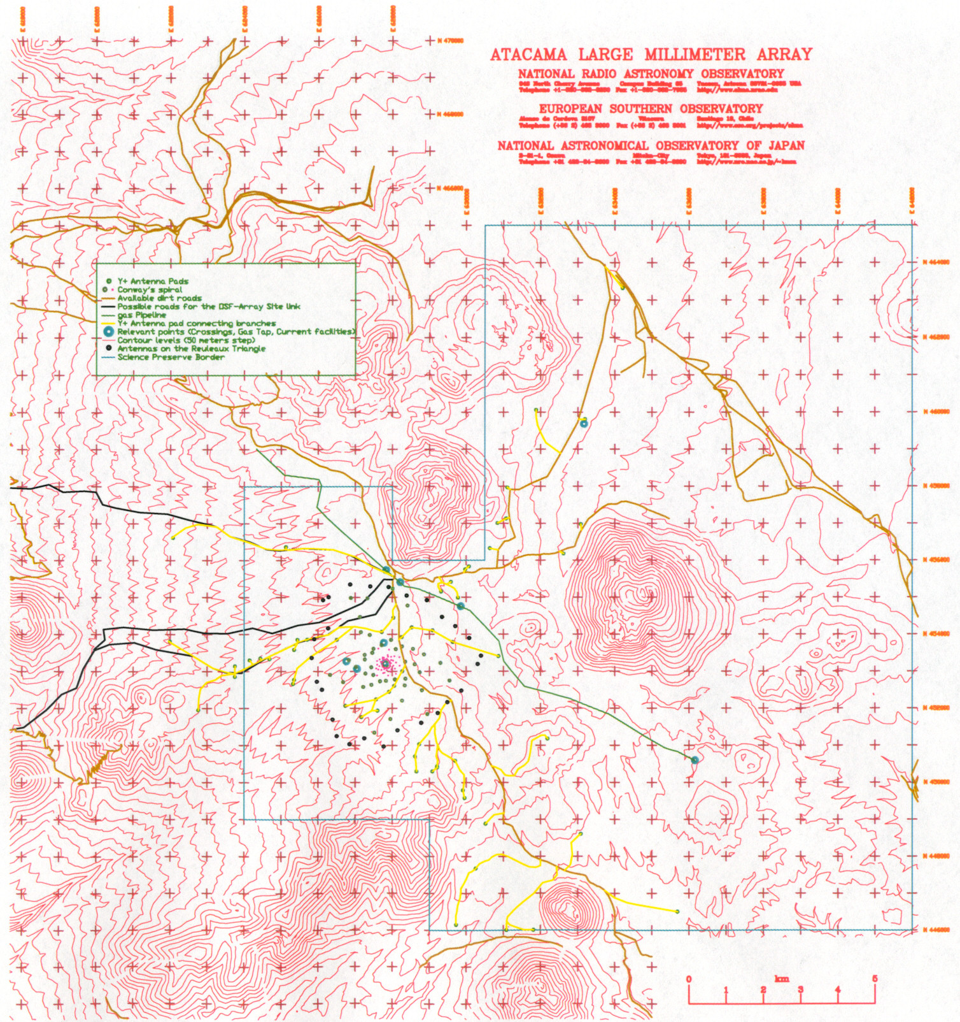
Figure 2: Layout of access roads to the antenna pads on the Y+ configuration.

Note: Black & White print outs or photocopies will likely be missing substantial information here. Go to the web version of this document for a better version of this figure. AutoCAD® version of this figure can be found at: ftp://ftp.tuc.nrao.edu/aotarola/yplus.dwg.

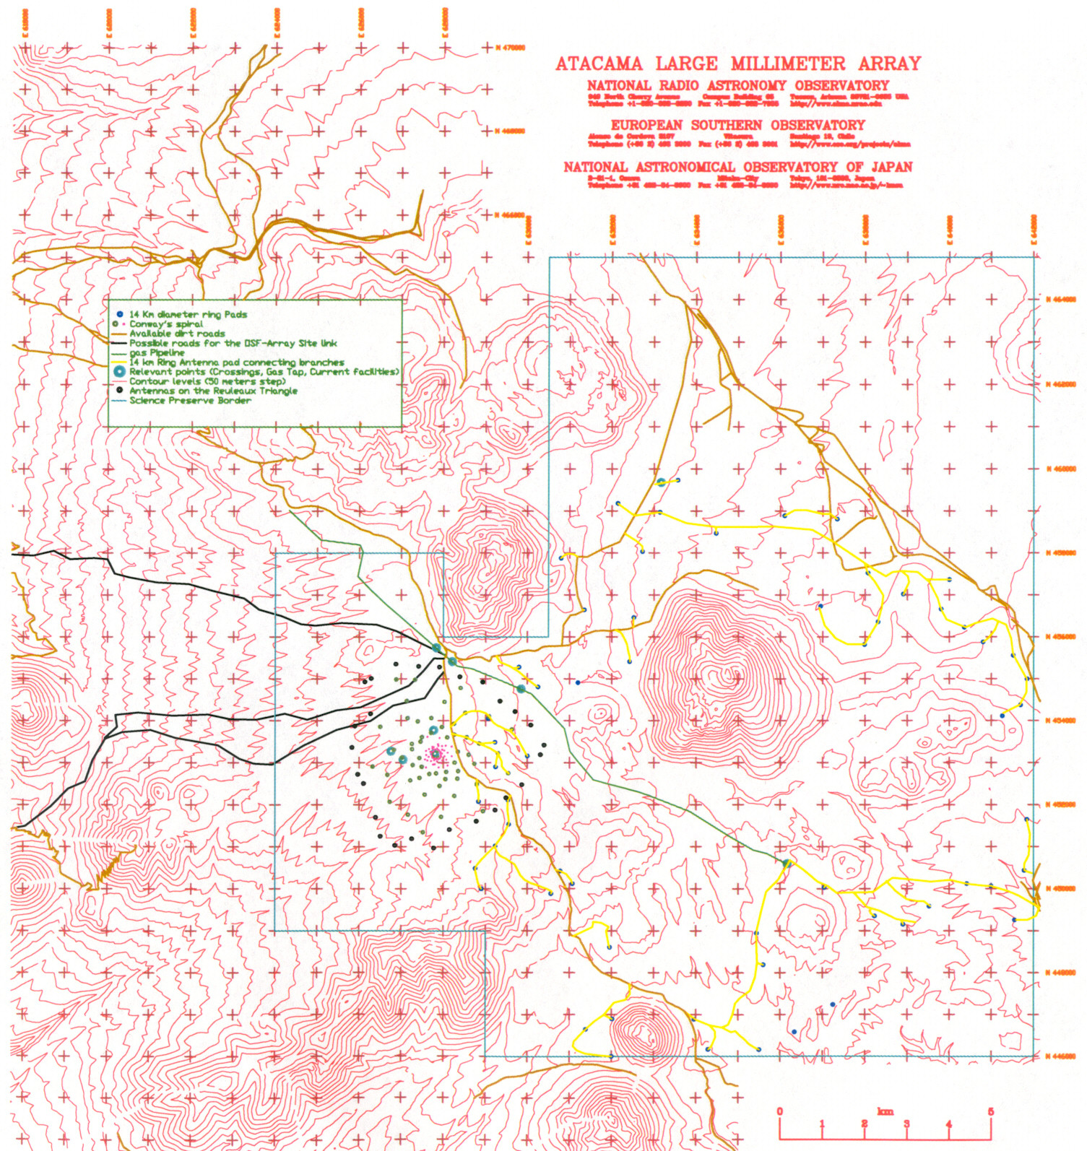
Figure 3: Layout of roads to access the antenna pads on the 14 km diameter ring.

Note: Black & White print outs or photocopies will likely be missing substantial information here. Go to the web version of this document for a better version of this figure. AutoCAD® version of this figure can be found at: ftp://ftp.tuc.nrao.edu/aotarola/14km_ring.dwg.

APPENDIX A
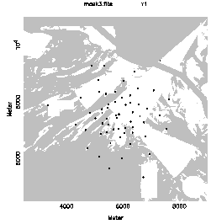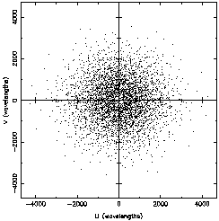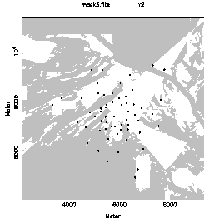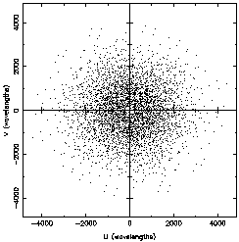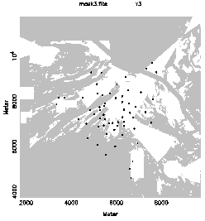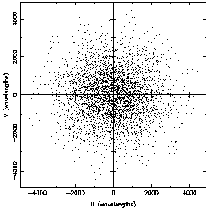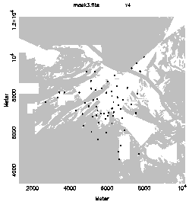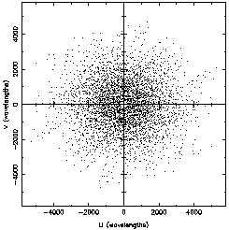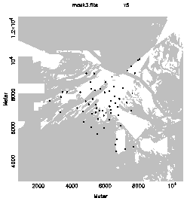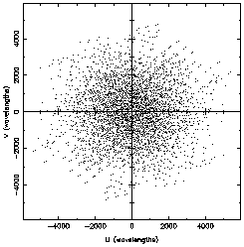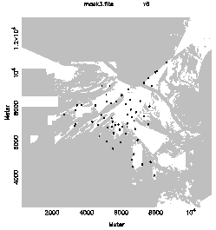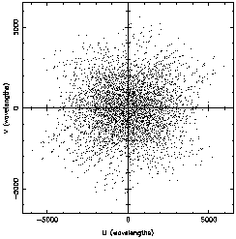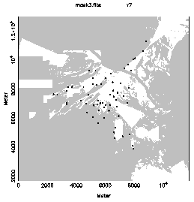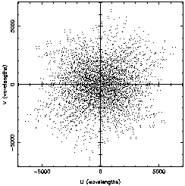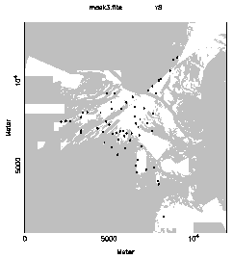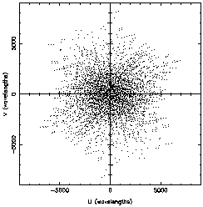
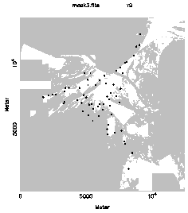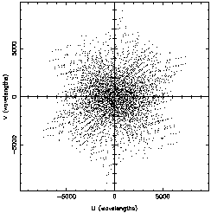
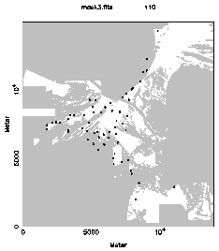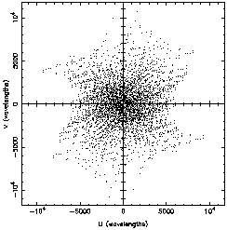
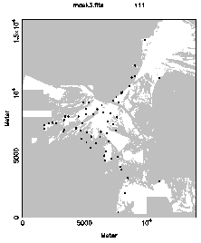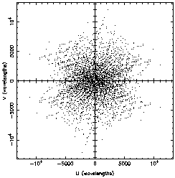
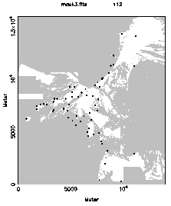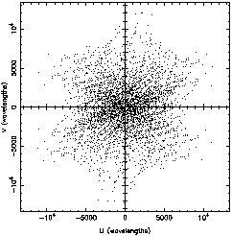
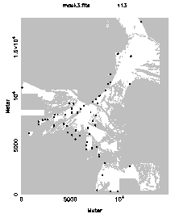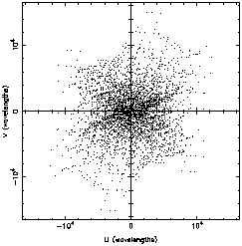
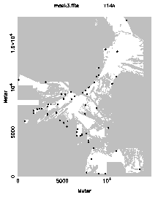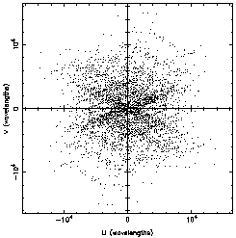

OSF-Site ~35 km, 14 km Ring ~70 km, East Access Rd ~14 km, SE road to Aspero ~10 km, Spiral ~30 km; Total ~159 km.

