ALMA MEMO # 413
PHYSICAL PARAMETERS OF THE CHAJNANTOR SCIENCE PRESERVE

Angel Otárola and Daniel Hofstadt
European Southern Observatory
Casilla 19001, Santiago 19, Chile

Simon J. E. Radford
National Radio Astronomy Observatory
949 N Cherry Ave. Tucson, AZ 85721-0655, USA

Seiichi Sakamoto
National Astronomical Observatory of Japan
Mitaka, Tokyo 181-8588, Japan

2002 March 18

Abstract – This document summarises previous studies of several physical parameters of the Chajnantor and Pampa La Bola sites: seismicity and volcanic hazard, geology, water availability, underground temperature fluctuations, and soil resistivity. Other parameters, such as the availability and quality of aggregates, the underground water supply potential, and the detailed characteristics of the weathering layer remains to be studied.

1. Introduction

Over the past several years, the National Radio Astronomy Observatory (NRAO), the Nobeyama Radio Observatory (NRO), and the European Southern Observatory (ESO) have arranged with external consulting professionals and companies for studies of several physical parameters of the Chajnantor and Pampa La Bola areas. These parameters are important for evaluating the costs of antenna pad construction, grounding protection systems, trenches for signal and power cables, road construction, and building foundations. Here we summarise the conclusions of ALMA Memos 230, 250, 251, 314, 326, 346, 369, and 408, and other documents describing the physical parameters. All conclusions should be credited to the authors of those memos because this paper is only a synopsis of what we know so far.

2. Summary of physical parameters

2.1.- Seismic hazard

The seismic hazard in the Chajnantor area was analysed in 1996 by Sergio Barrientos [1] from the Geophysics Department at the Universidad de Chile under agreement with NRAO. This report estimated the probability not to exceed a given surface acceleration at the ALMA site and also indicated a relation between the Mercalli (intensity) and the magnitude scales.

Barrientos considered all the recorded earthquakes between 21.0° and 25.5° south latitude and between 65.0° and 73.0° west longitude. From the location of the epicentres (figure 1), he concluded:

- Seismic activity is mainly confined to the Wadati-Benioff zone (the inclined plane dipping east from the Pacific trench) and
- No shallow activity occurs near the ALMA site (labelled with a star on the plot).

More important, based on the analysis of the magnitude and intensity of the recorded events, Barrientos inferred:

- “According to the seismic productivity levels of the region, its location along the Wadati-Benioff zone, and the ground motion attenuation relationship between distance and magnitude, it is expected that an acceleration of 25%g will not be exceed within 100 years at 90% probability levels” (figure 2).

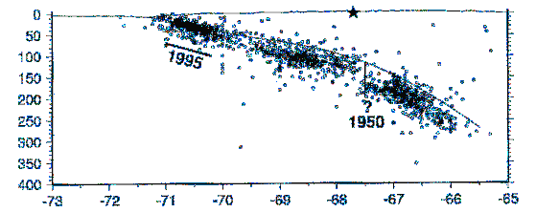
Figure 1: Earthquake epicenters recorded near the ALMA site. From [1]

Another source of Seismology information is the Regional Seismological Centre for South America known by its Spanish acronym, CERESIS. This international organisation, created in 1996 by an agreement between Peru and United Nations, is now an autonomous organisation sponsored by 12 countries including Chile. CERESIS maintains an Internet site with seismic information for South America [11]. Here Richard Kurtz found a plot indicating a 10% probability that surface acceleration will exceed 400 cm/s² (40% g) in 50 years at a location near the ALMA site (23°S, 68°W). In other words there is 90% probability surface acceleration will not exceed 40% g in 50 years. Based on this we can infer the probability to have a 25%g event in 50 years must be higher than what Barrientos concluded [1]. This apparent disagreement suggests a more detailed study of the seismic hazard at Chajnantor maybe necessary.

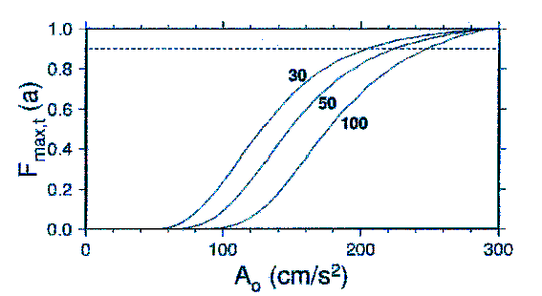
Figure 2: Probability to exceed a certain acceleration in 30, 50 or 100 years. From [1]

The crustal stability in the region of the ALMA site has been studied by the South American Geodynamic Activities (SAGA) project [13] since 1993 under the responsibility of the GeoForschungsZentrum at Potsdam University (Germany). The SAGA project consists of a GPS network extending from the west side of the Pacific ocean (Robinson Crusoe and San Felix islands) to the Argentinean Chaco at the latitude of Antofagasta. As of 2001July, this GPS network included a total of 215 GPS-Stations.
On 1995 July 3, a earthquake with a moment magnitude of M_{W}=8.0 occurred in Region II of Chile with an epicenter on the Pacific plate south of Antofagasta. Three months after this event, researchers from Potsdam University, assisted by local researchers, re-measured 70 of the 215 SAGA GPS stations to compute the vector motions caused by the earthquake (figure 3).

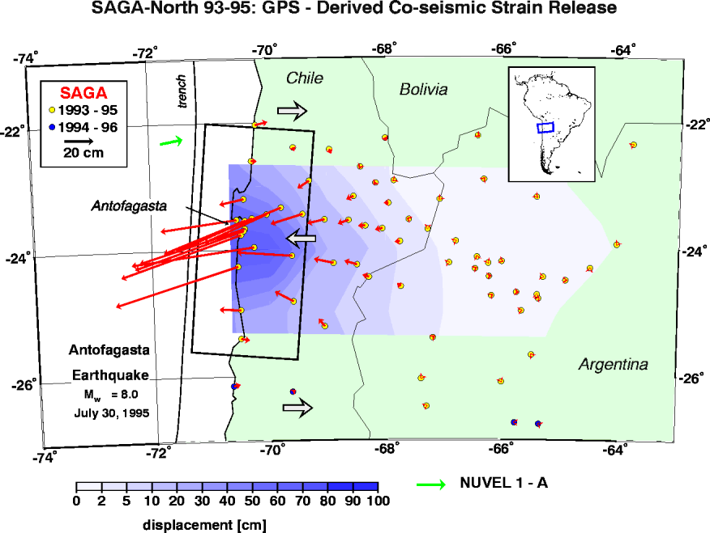
Figure 3: Observed horizontal displacements of the SAGA network stations after the 1995 July earthquake at Antofagasta. From [12]

According to Klötz et. al. [12], the vector motions (figure 3) are computed relative to GPS stations east of the Andes in Argentina where the motion was fixed to zero. Displacements are based on station positions measured 21 months prior to and 3 months after the 1995 Antofagasta earthquake. Displacements reached values of 90 cm at the coast in the vicinity of the epicenter and 10 cm at a distance of 300 km inland from the Pacific trench.

Complete data for all the SAGA stations re-measured after the 1995 earthquake are available [13]. Near the ALMA site, the measured displacements are much smaller than at the coast (table 1), in the range of about 15 mm.
Table 1: Measured displacements with respect to the fixed GPS stations
Station  Nº | Station  Place | Station  ID | West  Longitude  (deg) | South  Latitude  (deg) | Distance from Chajnantor (km) | East  Motion  (mm) | North  Motion  (mm) | Up  Motion  (mm) | Total Motion (mm)
40 | Linzor | LINZ | -67.999 | -22.259 | 88 (NNW) | 11± 3.3 | -22 ± 2.9 | 6 ± 9.2 | 25 ± 10.2
41 | Cerro Toco | CTOC | -67.855 | -22.928 | 15 (NNW) | -10±2.6 | -7±2.8 | 7±4.5 | 14 ± 5.9
42 | Paso de Jama | PAJA | -67.073 | -23.225 | 73 (ESE) | -6±2.6 | -7±2.8 | -12±4.3 | 15 ± 5.8

2.2.- Volcanism

A volcanism report was prepared by Moyra Gardeweg [2], a Chilean geologist working for the Chilean Geology and Mining Service, SERNAGEOMIN. She concluded:

- The ALMA site sits on welded pyroclastic rocks or ignimbrites that show extensive, nearly flat surfaces smoothed by glacial erosion. Volcanic cones of various sizes and ages, none of the closer ones active, surround the site.
- Welded ignimbrites are solid rocks with good mechanical properties. They are often used as building stone because of their strength and insulating characteristics.
- A major NS regional fault extending close to the ALMA site has apparently not moved for more than one million years (My), as suggested by the lack of displacement of 1.3 My old ignimbrites.
- Three volcanoes within a radius of 100 km are currently identified as active: Putana, Sairecabur, and Lascar. Lascar is the most active, with major eruptions in historic and recent times (1993). Putana is in a fumarolic state and Sairecabur shows evidences of recent fumarolic activity. Putana and Sairecabur have no records of historic activity and the chance they will erupt in the near future is low. Lascar, on the other hand, has a high probability of erupting soon.
- Because Chajnantor is at a considerable distance from any of the active volcanoes, lava flows, pyroclastic flows, volcanic landslides, and lahars do not pose a direct hazard. The hazard from volcanic gases and acid rain is also low as the downwind gas concentration becomes diluted by air.
- The most important volcanic hazard to the ALMA would be the deposition of fine-grained pyroclastic material (ash) during an explosive eruption of one of the three active volcanoes. The prevailing winds make this hazard larger in terms of size and thickness of material for Putana or Sairecabur, but the probability of eruption is lower than for Lascar.

The last major eruption of Lascar volcano occurred in 1993 when we were starting our site testing activities to identify a site for the LMSA and LSA projects. Another minor event took place on 2000 July 20. This was classified by SERNAGEOMIN, in an internal report written for the Chilean Emergency Office, as an “outgassing” caused by the accumulation of snow inside the crater. The 2000 outgassing can be seen in the picture taken by Robert Fosbury, who was attending a conference on Gravitational Lensing in San Pedro de Atacama at the time (figure 4).

2.3.- Geology

2.3.1.- First Geology Field Campaign (nine trenches)

During 1999 May, Geoconsultores S.A. conducted a field campaign to study the geology of the Chajnantor area under contract with NRAO and the supervision of ESO [3].

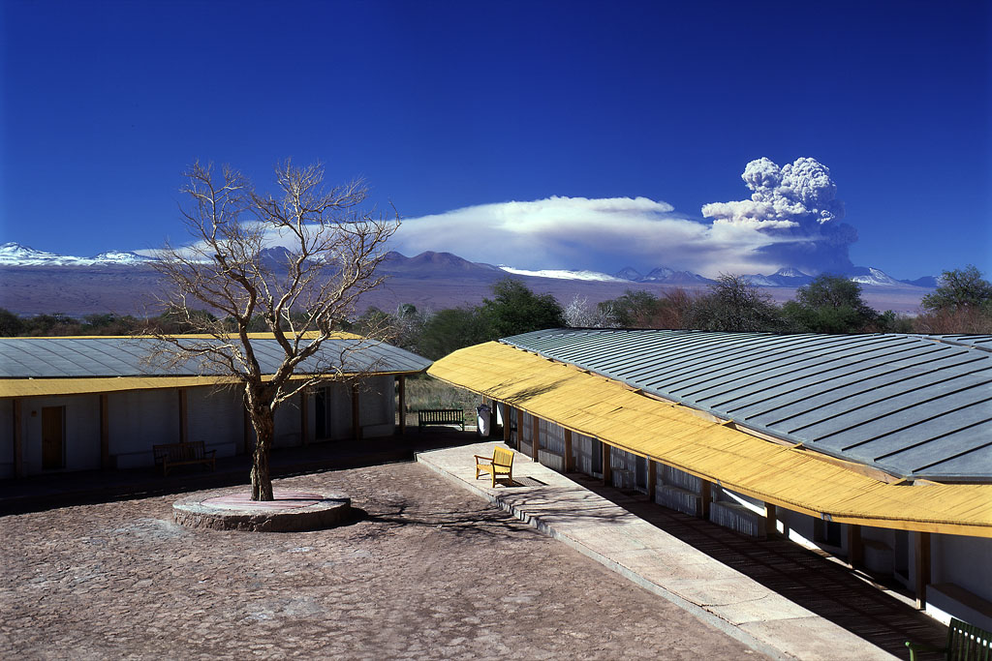
Figure 4: Out-gassing by the Lascar volcano (R. Fosbury).

For this first study nine trenches were excavated on the plateau (figure 5). The company checked the thickness and fragmentation of the weathering layer and took samples at several places for laboratory measurements of the cohesion of the rock mass (E_{i}) and other physical parameters.

Figure 5: Trench #6 (Geoconsultores)

The conclusions of the technical report [3] are the following:

- The surface layer corresponds to Ignimbrita Cajón and dates from the Pleistocene-Holocene within the last 0.8 million years. This layer covers approximately 450 km² in the Calama geological sheet and extends another 530 km² to the south. Its thickness ranges from 250 m to a few meters, thinning to the west. Ignimbrites are composed of pyroclastics flows, mainly dacitic and andesitic.
- To the NE of Purico Volcano (Co. Toco), the rocks are composed of moderately to weakly welded tuff with phenocrystals of plagioclase, quartz, biotite, and horneblend. The matrix is composed of pieces of glass and typically the flows contain a large amount of pumice. Chemically, they are classified as chalcoalcalines.
- It is proposed the ignimbrite cajón was formed by outflows from concentric fractures around Purico Volcano (Co. Toco).
- The tectonic structure shows very little disturbance by recent activity.
- Because of the presence of ground water and the potential for frost-defrost cycles, it will be necessary to embed the antenna foundations fairly deeply into the ground.

During the excavation of the trenches, there were places where the backhoe had difficulties, reaching only about 30 to 50 cm below the surface. In these areas the bedrock is very close to the surface and weathering is very low. In most cases, however, the rock had a tendency to break into flat slabs 20 to 40 cm long and a few centimeters thick.

In a different document [4], Luis Rojas, the geologist in charge of the geologic studies at Chajnantor, explained ice formation is the main mechanical agent responsible for the rock fracture.

Based on the preliminary geological research, Geoconsultores computed the Rock Mass Rating (RMR) for two conditions representing the best and worst conditions at Chajnantor: massive rock and a weathered rock (figure 6,).
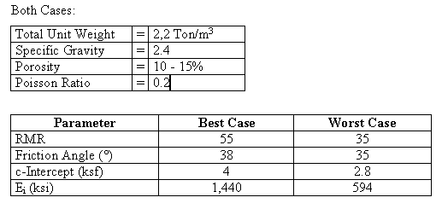
Figure 6: Rock Mass Ratingfor Chajnantor.

2.3.2.- Second Geology Field Campaign (six holes 15 m deep)

In 2000 February, Geoconsultores S.A. conducted a second field campaign under contract for NRO. This work addressed two questions that couldn’t be answered from the previous study: a) the thickness and the variations in thickness of the weathering layer and b) the quality of the bedrock.

The rock layers in the Chajnantor/Pampa La Bola area are a typical case of a weathering layer over massive bedrock. A cut along the Jama road is a good example of the ground structure within the science preserve (figure 7).

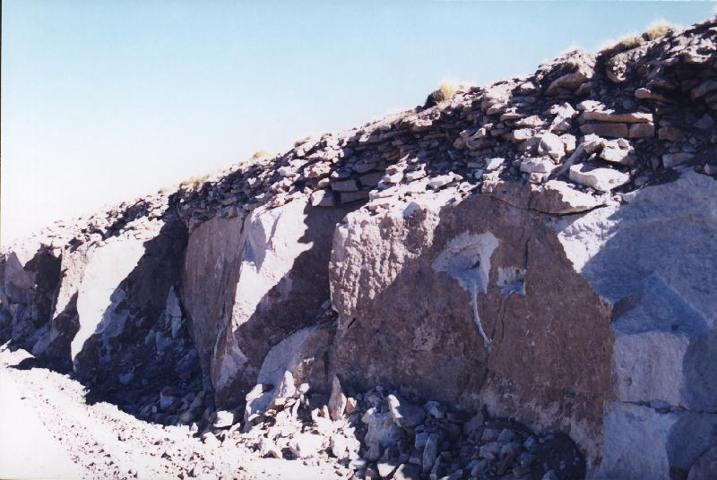
Figure 7: Cut along Jama road (A. Otárola)

The upper layer is composed of broken rocks a few cm thick and a few tens of cm long. This weathering layer is formed by frost-defrost cycles. Below the broken rock layer lies bedrock corresponding to the ignimbrites cajón reported by Gardeweg [2] and Geoconsultores [3].

Laboratory inspection of the 15 m vertical column samples revealed the weathering layer ranges from about 1.6 m to 7 m deep. The worst case is at the saddle point between Pampa La Bola and Chajnantor, where the depth to the bedrock is 15 m deep. The average thickness of the broken rock layer at four boreholes (not considering boreholes 5 & 6 as these point were considered extreme cases) was 2.3 m.

In 2000 March, we asked Geoconsultores to propose a method for obtaining a clear idea of the thickness and thickness variations of the weathered layer. Rojas [4] proposed a low energy, seismic sounding study to get a three dimensional view of the subsurface. This study would cost around US$50000 for 10 km of exploration lines. As of 2002 March, the proposal remains pending. This seismic sounding study might be useful to get a clear view of the weathering layer at the site selected for the location of the ALMA compact configuration.

An important consideration for the design and construction of the antenna foundations is the axial resistance of the rock. Geoconsultores measured this parameter in rock samples with a length-to-diameter ratio around two taken at a representative depth for the foundations (table 2).

2.3.3.- Third Geology Field Campaign

In 2002 January, Geoconsultores S.A. conducted a third geological campaign at Chajnantor under contract with ESO. The purpose of this campaign was to determine the bedrock depth at a few possible sites for the APEX Telescope and at representative antenna locations for the compact and intermediate ALMA configurations. Analysis of the samples and preparation of a technical report are underway. Preliminary information indicates, however, the bedrock is about 2 m deep at all of the borehole locations.

Table 2: Borings at Chajnantor and Pampa La Bola
# | Location | East  (m)  UTM  WGS-84 | North  (m)  UTM  WGS-84 | Total depth  of  bore  (m) | Depth to massive rock (m) | Specimen depth  (m) | Unit weight  kg/m³ | Ultimate axial resistance  kg/cm²
1 | Pampa  La Bola | 633650 | 7460200 | 15.2 | 1.6 | 2.0-2.2 | 2189 | 279
 |  |  |  |  |  | 1.4-1.6 | 2057 | 226
2 | ASTE site | 632940 | 7459040 | 15.3 | 3.6 | 3.5-3.75 | 2174 | 406
3 | Chajnantor  North | 627410 | 7454050 | 15.2 | 2.0 | 3.9-4.1 | 2128 | 202
 |  |  |  |  |  | 3.2-3.4 | 1998 | 113
4 | Chajnantor  South | 627610 | 7452850 | 15.0 | 2.0 | 2.3-2.5 | 2089 | 124
4 |  |  |  |  |  | 2.0-2.4 | 1993 | 216
5 | Saddle point | 631250 | 7455850 | 16.6 | 15.0
6 | Chascon East | 637710 | 7457280 | 15.0 | 7.0 | 7.4-7.6 | 1931 | 161

2.4.- Water Supply

In 1996, the Geologist Francisco Townsend [10] wrote a report about the water supply at Chajnantor. This brief work included a geological framework that agrees with the geological description of the site given by Gardeweg and by Geoconsultores. In addition, this report also includes some description of the hydrological and hydro-geological characteristics of the site and also the results of a water rights search base on checking two years (1995 & 1996) of the “Diario Oficial”.

The main conclusions of this work were the following:

- The site itself is over an ignimbrite layer, called Ignimbrita Cajón (Quaternary), and characterised by light pink tuff outcrops. The quality of the normal ignimbrite outcrops in the area allows construction of a road for heavy trucks with a normal gravel-shale basement.
- The Salar de Atacama basin is bounding the site to the west and the Salar de Pujsa to the east. Both are closed basins with minimum elevations of 2500 m (Atacama) and 4500 m (Pujsa). Water communication between the two basins could exist below the ignimbrite layer.
- There are no permanent surface water flows at the site. There is , however, a small lagoon named Laguna de Agua Amarga to the south of Cerro Chascon and a water spring system (Aguada Pajaritos) on the north flank of the Purico Volcano (Co. Toco). This spring is fed by water infiltration from snow on the upper slopes of the volcano. The water remains on the surface at lower elevation but also infiltrates underground. The water flow is about 0.5 liters/sec.
- Ignimbrites are capable of developing an aquifer with a high potential for an underground water supply. Because Chajnantor is on the border of a hydrological basin, however, this potential is strongly reduced. Townsend proposed a gravimetric and geological research (100 m deep) to check the underground water potential at Chajnantor.
- At the time of the study, and by checking El Diario Oficial for 1995 and 1996, no water rights claims were found in the area. This indicates no water rights exist at all because water rights must be renewed every two years according to Chilean law.
Townsend only studied the areas surrounding the Chajnantor site, including the section north of Toco where the Aguada Pajaritos is easy to identify where the surface water flow crosses the Jama road. The lagoon located at Quebrada de Quipiaco was not studied. As far we know the water rights for that area are under control of the Indian Rights National Commission (CONADI).

2.5.- Sub-surface temperature fluctuations

During 1997, the NRAO installed a probe near its container to measure the temperature right at the surface and at depths of 10, 20, and 30 cm [9]. These temperatures were logged from June through October 1997. The time series measured for 1997 June (figure 8) is an example of the data gathered with the temperature probe.

The focus of the analysis was computing the thermal diffusivity of the soil and the damping of diurnal temperature variations with depth.

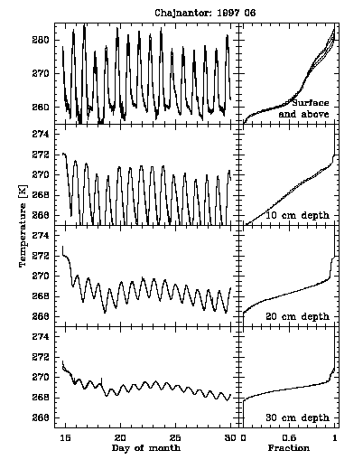
Figure 8: Surface temperature time series (June 1997)

The most important point to checking the temperature fluctuations at different depths. Temperature variations affect the physical length of signal cables (between each antenna and the correlator room), introducing unwanted phase changes in the LO reference signal and the IF signals. The analysis of this data also contributed some information to understanding the subterranean freezing and permafrost.

The main conclusions were:

- As expected, temperature variations are much smaller below ground than at the surface and the amplitude decreases with depth.
- There is no systematic seasonal trend in the median sub-surface temperatures and month-to-month variations are less than 1.5 K at any depth.
- Storms with associated snowfall dramatically disrupt the diurnal cycle. The snow has a clear insulating effect on the sub-surface temperatures.
- Thermal diffusivity was determined both from the amplitude decrease with depth and from the delay increase with depth. Both methods indicate the diffusivity is in the range (1-5) x10⁻⁷ m²s⁻¹ and with an overall median of 2.4x10⁻⁷ m²s⁻¹.
- For the maximum observed diffusivity, 5.0 x10⁻⁷ m²s⁻¹, the diurnal (24h), temperature variation at a depth of 1.0 m is attenuated to only 0.02% of the surface amplitude and is delayed by 33h. Because the diurnal temperature variation at Chajnantor is almost always less than 30 K at the surface, the amplitude variation at 1m depth is less than 6mK and the maximum rate of change will be 1.6 mK hr⁻¹.
- For the kind of fiber planned for ALMA, a 25km fiber buried at 1.0 m in depth will experience a diurnal change in length of 2.25 mm with a maximum rate of 0.6 mK hr⁻¹.

2.6.- Ground Resistivity

Because of its relevance for the design of proper grounding and cathodic protection systems for the ALMA antenna foundations, the ground resistivity has been measured at several different places around Pampa La Bola and Chajnantor by Seiichi Sakamoto and collaborators [6, 7, & 8].

Measurements at the six bore hole locations and the NRAO and NRAO/ESO equipment sites illustrate the soil resistivity and seasonal variations in the Science Preserve (figure 9).

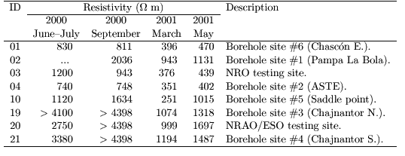
Figure 9: Ground Resistivity at Pampa La Bola and Chajnantor. From [8].

The main conclusions are:

- In the austral summer the ground resistivity was about 300 Ωm at the selected locations on the Pampa La Bola and about 1000 Ωm at the selected locations selected on Chajnantor site.
- The ground resistivity is about three times lower in the late summer (March) than in the winter (June-July) (figure 9). Hence the maximum ground resistivity at Pampa La Bola is about 1000 Ωm and at Chajnantor about 3000 Ωm.
- Diurnal variations of upper soil resistivity are attributable to variations of the upper soil temperature.

3.0.- Final Conclusions

The final conclusions of this report are summarised in Table 3.
Table 3: Summary of physical parameters measured at the Science Preserve Area.

Item | Parameter under study | Variable | Description
1 | Seismicity | Surface acceleration | 25%g (~250 cm/s²) will not be exceed within 100 years at 90% probability level.
2 | Seismicity | Local earthquakes | Local earthquakes at the ALMA site are produced at about 100 km in depth and are greatly attenuated when they reached the surface.
3 | Volcanism | Active volcanoes | The three active volcanoes near the ALMA site are Putana, Sairecabur, and Lascar.
4 | Volcanism | Eruptions | Last eruption by Lascar ocurred in 1993 but an “outgassing” event took place in 2000 July.
5 | Geology | Bedrock | The bedrock at the Pampa La Bola and Chajnantor site is classified as Ignimbrites.
6 | Geology | Bedrock | The thickness goes from about 250 m to a few meters, thinning westwards.
7 | Geology | Weathering Layer | The broken-rock layer is composed of horizontal slabs 20-40 cm long and a few cm thick.
8 | Geology | Weathering Layer | The mechanism responsible for the weathered layer is the frost-defrost cycle.
9 | Geology | Weathering Layer | The thickness of the weathering layer was found to be up to 15 m (saddle point between Pampa La Bola and Chajnantor). The average thickness is about 2.5 m.
10 | Geology | Stability | The geological structures show very little disturbance by recent activity.
11 | Geology | RMR | The Rock Mass Rating analysis classified the rock-bed as “fair rock” with and E_{i} factor of about 1440 ksi (best rock) and about 594 ksi (worst case).  1 ksi = 6.9 kPa.
12 | Water | Hydrogeology | The ignimbrites are capable of developing an aquifer with a high potential of underground water supply.
13 | Water | Hydrogeology | The site is located in between two basins, Salar de Pujsa basin to the east and the Salar de Atacama basin to the west.
14 | Water | Hydrogeology | Water must flow underground from the higher to the lower hydrological basin.
15 | Water | Legal rights | No water rights were found to exist on the Science Preserve Area in the study made covering the 1995 and 1996 years.
16 | Sub-surface Temperature | Amplitude  variation | At 1m in depth, is about 0.02% of the amplitude at the surface.
17 | Sub-surface Temperature | Thermal diffusivity | Median value 2.4 x10⁻⁷ m²s⁻¹
18 | Sub-surface Temperature | Fiber length variation | For the diffusivity characteristics of Chajnantor, the diurnal variation for the length of a 25 km fiber, buried 1 m below the surface, will be 2.25 mm.
19 | Ground resistivity | Absolute value | The ground resistivity at the Pampa La Bola site in winter season is in the order of 1000 Ω-m
20 | Ground resistivity | Absolute value | The ground resistivity at the Chajnantor site in winter season is in the order of 3000 Ω-m
21 | Ground resistivity | Seasonal variation | The ground resistivity at both sites decreases a factor of three duing the summer.
22 | Ground resistivity | Diurnal  variation | Diurnal variations in the ground resistivity are due to temperature fluctuations of the ground.

Bibliography

[1] S.E. Barrientos, ALMA Memo 250, June 1996, Seismicity and Seismic Hazard at MMA site, Antofagasta, Chile.

[2] M.C. Gardeweg P., ALMA Memo 251, August 1996, MMA Site East of San Pedro De Atacama, North Chile Volcanic Hazards Assessment and Geologic Setting.

[3] Luís Rojas, Geoconsultores S.A., May 1999, “Geological report for NRO-NRAO”.

[4] Luís Rojas, Geoconsultores S.A., March 2000, Document GEO N°2000/139, quotation sent to ESO.

[5] Luís Rojas, Geoconsultores S.A., ALMA Memo 408, Geotechnical Study at Chajnantor Site, II Region, NRO-NRAO.

[6] Seiichi Sakamoto, Hajime Ezawa, Toshikazu Takahashi, and Nobuyuki Yamaguchi , ALMA Memo 326, October 2000, Vertical Profiles of Soil Resistivity at Pampa La Bola and Llano de Chajnantor Locations
[7] Seiichi Sakamoto and Tomohiko Sekiguchi, ALMA Memo 346, January 2001, Spatial Distribution of Near-Surface Soil Resistivity in the Cerro Chascon Science Preserve

[8] Seiichi Sakamoto, ALMA Memo 369, May 2001, Seasonal and Diurnal Variation of Upper Soil Resistivity in the Cerro Chascón Science Preserve.

[9] Laura A. Snyder, Simon J. E. Radford, and Mark A. Holdaway, ALMA Memo 314, June 2000, Underground Temperature Fluctuations and Water Drainage at Chajnantor

[10] Francisco Townsend G., INVEREX, MMA Memo 230, June 1996, Preliminary Report on Water Supply, Millimeter Array Project, National Radio Astronomy Observatory
[11] CERESIS, Seismic risk map for South America at: http://sipan.inictel.gob.pe/ceresis/

[12] J. Klotz, D. Angermann, G. W. Michel, R. Porth, C. Reigber, J. Reinking, J. Viramonte, R. Perdomo, V. H. Rios, S. Barrientos, R. Barriga, O. Cifuentes. GPS-derived Deformation of the Central Andes Including the 1995 Antofagasta M_{w} = 8.0 Earthquake, Pure appl. geophys. 154: pp 709-730

[13] SAGA Project homepage: http://op.gfz-potsdam.de/S11/main_SAGA.html

Large Millimeter and Sub-Millimeter Array
Large Southern Array
1 ksi corresponds to 6.9 kPa
1 ksf corresponds to 47.0 kPa
APEX stands for Atacama Pathfinder Experiment.
1 kg/cm² corresponds to 98 kPa.

